# Introduction

Robots are important in many industries, but they are different with other machines. For example, a single CNC machine gives high performance for a specific machining task, while single robot can achieve many tasks with a different performance for each because to the customized end effector. Robots are good at performing tasks that are too repetitive or dangerous for human to do such as welding, assembly and CNC operations.

Robots can be classified according to kinematic structure. A robot is said to be a serial robot (fig.1.1 a) or serial (open-loop) manipulator if its kinematic structure takes the form of an open loop-chain, a parallel manipulator (fig.1.1 b) if it is made of a closed-loop chain (Pandilov & Dukovski, 2014). Parallel robots have such advantages as high speed and acceleration, high stiffness and high accuracy. However, the drawbacks are also obvious such as low workspace/robot size ration, complicate calibration. As considering the features of both robots, serial robots are widely used on assembly line and parallel robots take the role in picking goods on conveyer belts.

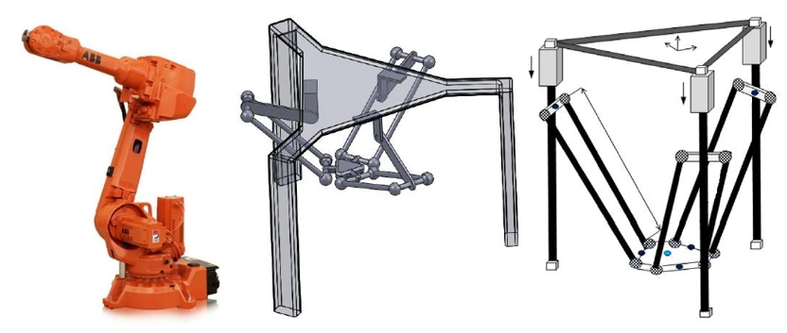

Figure 1.1. serial robot, parallel robot and linear delta robot

Delta robots are those parallel robots with three mechanism chains and it is believed that the first delta robot is designed by Clavel who uses parallelograms mechanisms and moving platform to create a robot with three translation and one rotation degree of freedom with respects to the base (Clavel, 1990). The application of delta robots begins in packaging industry in 1987, and it became one of the most successful commercial robots; in 1999 ABB Flexible Automation launched their delta robot “FlexPicker” which aimed at food, pharmaceutical and electronics industry (Bonev, 2001). Recently, parallel robots have found a place in households in the form of 3D printing which is called delta 3D printer, such products bring convenience to the creators for building plastic prototypes or doing experiments. For most of the mass production delta 3D printers, the end effector is driven by three linear actuators, as the result, they are also called linear delta robots.

The delta robots have attracted great interests not only in industry but also in academia. Variants of modified delta robots are built in university labs, for example, University of Maryland, University of Genoa and University of Western Australia (Bonev, 2001). At the same time, varies of researches have been carried out on robot workspace, dynamics and kinematics; methods of improving accuracy and performance are also analyzed. Generally, the method of researching a robot includes two essential steps. The first step is to analyze the kinematics equations which includes forward kinematics and inverse kinematics. Then the maximum workspace can be defined by numerical method or setting limits on the kinematics equations. Meanwhile, trajectory generation is another research direction, which focus on the velocity, acceleration, jerk for each degree of freedom.

The drawbacks of delta robots are obvious by including current researches, which is the kinematics problem of a parallel robot is (Liu, et al., 2003) complex. It does not mean that the kinematics cannot be solved, but hard to be solved with numerical method with high efficiency. The main reason is that the end effector has to be connected to the base with at least two legs. For such reasons, delta robots have the disadvantages in terms of relatively small useful workspace. According to XXX’s explanation, the workspace is one of the most important criteria of evaluating a robot’s performance, because it determines the area that the end effector can reach.

The linear delta robot has different kinematics with those invented by Clavel, but almost all the current products are designed with an enclosed shape (Isosceles right triangle) which leads to a problem that the size of the robot is larger than the maximum workspace. But one fact has been ignored by many studies, the motion of one single chain can be seen as transferring horizontal motion into vertical direction, which means delta robots can be designed foldable.

However, there is still no design used the advantage of the foldable structure. So, it is necessary to find out whether a foldable structure is feasible on linear delta robots to increase their workspace and robot size proportion. Nevertheless, the home 3D printer customers are complained about the unstable control system which leads to part failure and material wastes, so it is also necessary to research on the control algorithm, hardware chosen, manufacturing method, commanding rules and motor specifications to find out whether these aspects affect the usage of linear delta robots.

## Project Aims

Based on the problems that presented above, it is clear that the function of a domestic parallel robot is rare (only 3D printing), and researching on the mechanism and control algorithm of the delta robot is valuable. And on that conclusion the aim of doing this project is defined as to solve the problems that limit the usage of linear delta robots by improving the robot structure and control method.

In order to achieve the aim a new robot will be designed and the prototype of the new design will be manufactured and assembled; besides, the control algorithm will be programmed and tested on a microcontroller. The main points include analysing the relationship between robot specifications and its workspace; the robot structure designing and embedded system programing.

## Project Objectives

According to the project aim explained above, it is clear that this project can be divided into two parts, one is to design the structure, another is to design the control system. And there are five objectives.

Objective 1: Analyse the robot workspace

This objective is to build the theoretical model of the robot and determine the robot parameters.

Workspace is an important criterial to distinguish between a CNC machine and a robot. The purpose of workspace analysis is to determine the robot parameters. The processes include defining customer’s needs on workspace shape, robot size,

Objective 2: Design the linear delta robot

This objective is to design the mechanism of the robot based on theoretical models. There are always varies of designs come from one theoretical model, by analyzing comparing and evaluating these designs to define a balance solution. So variant models will be designed and analyzed, and an improved one will be manufactured and assembled as the prototype.

Objective 3: Design the control system on a micro controller

This objective is to design a fundamental structure of the control software. Such structure should show how the software works, and the functions needed. Before the design it is necessary to select a proper microcontroller, because useful hardware resources may make this process straight forward.

Objective 4: Design the trajectory planning algorithm

Trajectory describes the position, velocity and acceleration of each point on a path. The trajectory planning algorithm is to convert user’s command to a trajectory. A lot of equations and calculations will be presented during this objective.

Objective 5: Design the motor control algorithm

The motor control algorithm is to adjust the motor speed and acceleration. There will be some calculations to determine the relationships between motor parameters and physics dimensions. But the main focus of this objective is on the principle of driving motors with the hardware.

For the rest of this report, the researches that have been done will be presented as a literature review. The literature review will focus on what method or theory has been used in another research or design. Then, A chapter that explained what method used specifically in this project will be presented. After that, the design outcomes and some tests results will be shown. The results will be discussed in chapter 5, as well as the effect and performance of the method selected. Finally, this report will end with a conclusion.

# Research and Literature Review

The introduction is often followed by a literature review relating to important aspects of the project being undertaken. This section will give the reader a clear and concise outline of the research which has been carried out and an analysis of what the findings from the research mean in relation to the rest of the project. 3300 words

This research is aimed to provide technical schemes to the design by discovering and analyzing current linear delta robot samples and product related technology and theory. The research begins with

## Current 3D printers

With the development of low-cost micro controller and fused deposition technology, sales of home 3d printers are rising year by year. At the same time, home 3D printers with delta robot structure have a certain share in the market, according to the data from Amazon, 3D printers priced under $ 300 have higher sales, from which the three most sold printers are listed in table 1

|  |  |  |  |  |  |
| --- | --- | --- | --- | --- | --- |
| 3D Printer | Print Area (mm) | Min. Layer Height (mm) | Max. Print Speed (mm/s) | Materials | Market Price |
| Monoprice Mini Delta | ø110 x 120 | 0.05 | 150 | 1.75mm ABS, PLA | $159.99 |
| BIQU Magician | ø100 x 150 | 0.1 | 70 | 1.75mm ABS, PLA | $169 |
| Anycubic Kossel Linear Plus | ø230 x 300 | 0.1 | 60 | PLA, ABS, HIPS, Wood | $200 |

Table 1. Current home 3D printers

<https://all3dp.com/1/delta-3d-printer-best-3d-printers/>

According to the table, the resolution of most of the robots on the vertical axis is 0.1mm, the maximum printing speed is about 60mm/s to 70 mm/s, and all of these printers can print ABS and PLA materials. The structure of Delta 3D printers can be divided according to the motor position; an upper motor printer is shown in figure 2.1.1(b), the motor, controller and power supply are placed at the top of the printer. The lower motor printer is shown in figure 2.1.1(a)(c), the motors, hod bed and controller is placed at the bottom of the printer while the power supply is placed beside the printer.

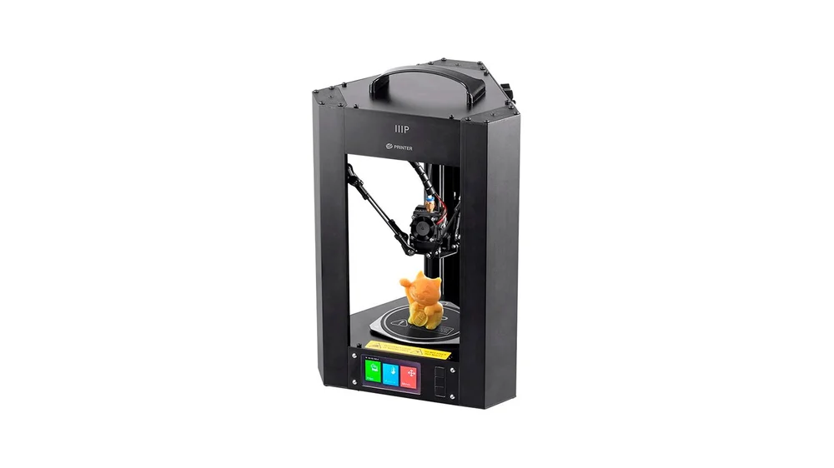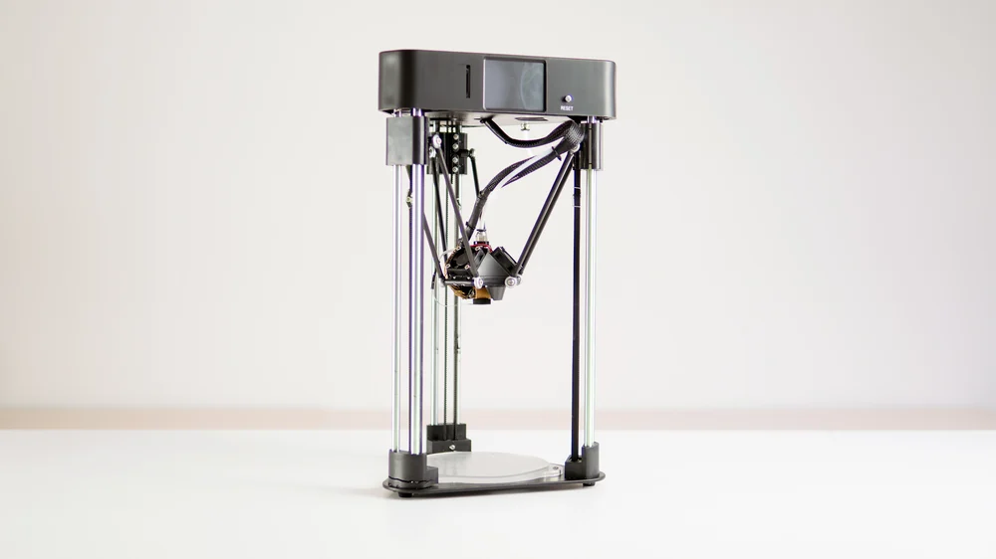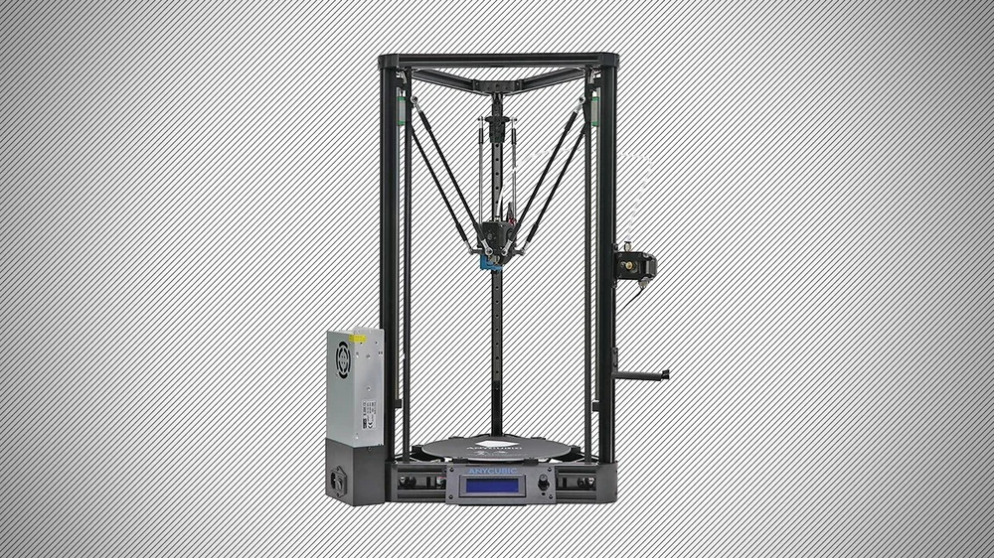

Figure 2.1.1 (a) – Monoprice Mini Delta

Figure 2.1.1 (b) – BIQU Magician

Figure 2.1.1 (c) – Anycubic Kossel Linear Plus

Most of the printer manufactures use NEMA 17 stepper motor, Arduino Mega controller and RAMPS 1.4 combination with A4988 stepper drivers. One reason is that plenty of opensource control firmware such as Marlin GRBL and Klipper can be used directly on these hardware. The functions of the firmware are:

1. Interprets g-code into motion, controlling the motors

2. Takes notice when limit switches are activated

3. Send response when commands are executed or a problem occurs

Which can be summarized as accepting inputs, driving actuators and sending feedbacks.

However, in the open source community such as Openedv and Stackoverflow, hobbyist found a lot of alternatives to improve the printer performance.

Using DRV8825 motor driver is recognized as an efficient way to improve the printer resolution, because the DRV8825 offers 1/32-step microstepping while the A4988 only goes down to 1/16-step. Besides, The DRV8825 has a higher maximum supply voltage than the A4988 (45 V vs 35 V), which means the DRV8825 can be used more safely at higher voltages and is less susceptible to damage from LC voltage spikes

## Machine Structure

Generally, the relationships between the end effector and carriages can be determined by solving the kinematics, but parameters might be different if the tool or part size is changed. This section is to research on the configuration file of Marlin firmware to find out the parameters needed to define the kinematics on a real product.

The CAD drawing of a typical linear delta robot is shown in figure 2.2.1. The robot consists of three towers which is labeled as A, B and C; the slider labeled Bi on each tower is called the carriage, rods, carriages and the end effector are connected with universal joints. Line od action represents the ideal position of a single mechanical chain, which will be used in workspace calculation.

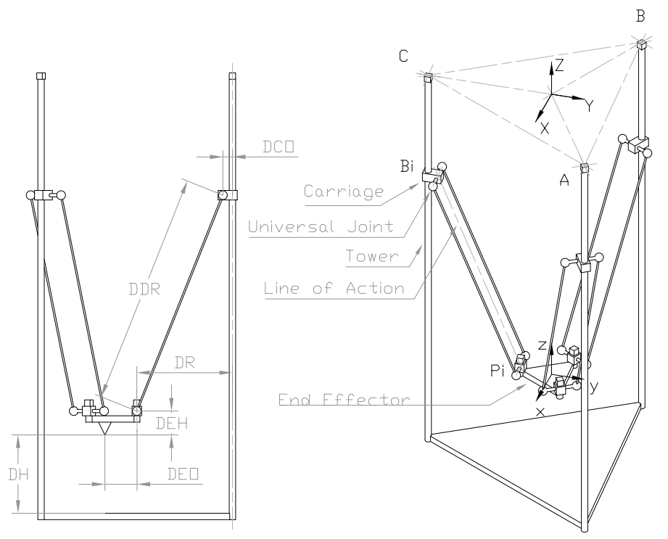

Figure 2.2.1 – CAD drawing of a linear delta robot

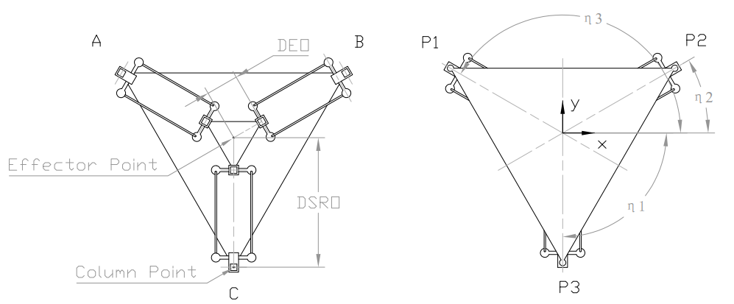

Figure 2.2.2 – top view of the CAD drawing of a linear delta robot

The robot can be described by 8 variables. DDR represents DELTA_DIAGONAL_ROD in Marlin, which means the centre-to-centre distance of the holes in the diagonal rods, generally the length of line of action equals to DDR; DTO represents DELTA_TOWER_OFFSET which is the horizontal offset from the middle of the robot to tower centre; DEO represents DELTA_EFFECTOR_OFFSET which is the horizontal offset of the universal joints on the end effector; DEH represents DELTA_EFFECTOR_HEIGHT, which is the vertical distance from the universal joints to the bottom of the end effector; DCO represents DELTA_CARRIAGE_OFFSET, which is the horizontal offset of the universal joints on the carriages; ηi represents DELTA_TOWER_ANGLE_TRIM, which is a set of angles that measured in degrees anticlockwise looking from above the robot (Graves, n.d.). All the variables mentioned above will be defined as macros and placed in the configuration head file.

In addition, there are two variables that can describe the state of the robot. DH represents DELTA_HEIGHT, which is the distance between work plane (such as 3D printer hot bed) and bottom of the end effector (such as 3D printer nozzle or pen peak), such variable will be used in describing the end effector position; DR represents DELTA_RADIUS which is the horizontal distance bridged by diagonal push rods when effector is centred (Graves, n.d.), such variable is used to check the limit.

## Choice of microcontroller

Basically, the controller performance not only infects printing speed but also infects the tolerance of code optimization. The STM32 is seems as an alternative of the Arduino Mega, according to table 2.3, the price difference between the two controllers is not large, IOs, timers and PWM ports of both controllers are the same.

|  |  |  |  |  |  |
| --- | --- | --- | --- | --- | --- |
|  | IOs | Timers | EXTI | PWM Ports | Cost |
| Mega 2560 | 100 | 14 | 6 | 8 bit 15 channels | ¥308.00 |
| STM32F407 | 100 | 14 | 6 | 16 bit 24 channels | ¥299.00 |
| STM32F103 |  |  |  |  |  |

Figure 2.3. comparison between microcontrollers

AVR mega 2560 is an 8-bit micro controller that supports the Arduino library (Pearce, 2014), so that register operations can be replaced with C functions, however, overly streamlined function library makes functions single. The reason of using Arduino is that the skills necessary to create an automated scientific tool were often not worth the investment of a researcher in a much different field.

STM32 is a 32-bit commercial controller, which can be programmed with either register operation, standard library or Hal library. Thanks to the two electronics company Alientek and Embedfire, free teaching materials and data manuals can be found in the open source communities, which brings convenience to novices. Besides, debug probes such as ST-Link and J-Link provides run-time variable monitor software such as STM Studio and J-Scope so that the output can be plot on a scope.

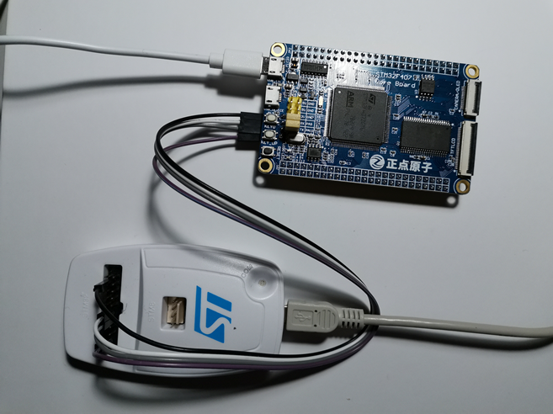

STM32F407 controller with ST-Link V2 debugger

The main difference between STM32F4 series and STM32F1 series is that the new cortex M4 chip is embedded with a float point unit (FPU). According to (Barr & Massa, n.d.), manipulating float is only recommended on those controllers with FPU, because the compiler-supplied floating-point library contains a set of software subroutines which is recognized as IEEE 754 standard that emulate the instruction set of a floating-point coprocessor. However, there is still a solution, which is to reimplement the calculations themselves using fixed-point arithmetic only. The decimal fraction can be presented as integer by multiplying an integer such as 10 or 100.

## Manufacture Method

Production models use Aluminum rods as the structure, and injection molding plastic parts as joints. However, injection molding is costly and not suitable for building protypes, an alternative is to use 3D print parts, such idea comes up with the RepRap project. The RepRap project has created 3-D printing machines that can manufacture approximately half of their own parts (57% self-replicating potential excluding fasteners, bolts and nuts) from sequential fused deposition of a range of polymers and common hardware. Then the problem is to select the material.

### AM and 3D print

3D printing with reference to AM is enabling technology for a wide range of new polymer products. This method is currently reforming the commercial manufacturing sector for the

polymer industry and aims to replace the injection moulding where the problems of melt line and weld line when the materials meet up within the mould could be overcome.

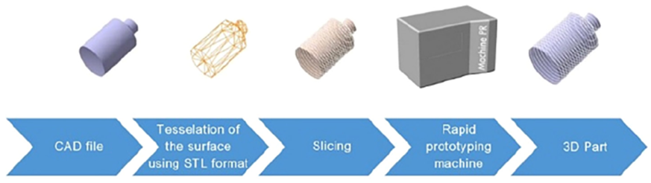

### Fused deposition modelling

Fused deposition modelling (FDM) is the most commonly used 3D printing method for thermoplastics materials, mainly due to its ease of handling, rapid processing, simplicity, and cost-efficiency. FDM is a simple additive manufacturing technology in which a thermoplastic filament is extruded through a circular nozzle to build 3D objects layer by layer

### Material selection

PolyLactic Acid (PLA) and Acrylonitrile Butadiene Styrene (ABS) are the two materials that are widely used on home 3D printers. The cost and properties are listed in table

|  |  |  |  |  |
| --- | --- | --- | --- | --- |
|  | Cost | Tensile Strength | Young’s modulus | Elongation break |
| PLA |  |  |  |  |
| ABS |  |  |  |  |

Table 2.4.1 – specification of 3D printer material

However, the manufacturing process affects the material properties. According to (Lay, et al., 2019), the tensile strength of FDM printed PLA, ABS are found to be 48% and 34%, lower compared to those fabricated using injection moulding. Young’s modulus of ABS using FDM are comparable with the injection moulded samples with percentage differences of 18.9% respectively.

Another experiment done by (Rao & Harshitha, 2019) pointed out that Results obtained are seen through analysis using ANSYS software. From the Table 7, the deficiency of both ABS and PLA bolts occur at a force of 270 N and 300 N respectively from the Table 7. The shear stress for ABS Bolt is 3.69 MPa and PLA is 4.1 MPa respectively. Hence it is proved that material ABS is weaker than PLA material. Equivalent stress for ABS is 3.6 MPa whereas for PLA it is 3.87 MPa respectively. Though there is slight variation in between them comparatively ABS is weaker than PLA.

## Current Method of Commanding

Most of the current firmware such as Marlin, GRBL and Klipper use G-code as the input. Current G-code standard is also known as RS-274 which was settled by the Electronic Industries Alliance in the early 1960s. Such standard specified the two basic motions: Linear motion and Arc motion (Kramer, et al., 2000).

### Linear motion command

Linear motions are often labelled as G0 or G1. nominally, each axis moves at constant speed and all axes move from their starting positions to their end positions at the same time. Coordinated linear motion can be performed either at the prevailing feed rate, or at traverse rate. If physical limits on axis speed make the desired rate unobtainable, all axes are slowed to maintain the desired path. The difference between G0 and G1 is different in different firmware. For example, both commands have the variable of feed rate in Marlin, and end effector variable such as printer extrusion rate can only be set with G1; however, the feed rate of G0 is a constant in GRBL firmware (Skogsrud, 2009).

### Arc motion command

Arc motions are labelled as G2 or G3. Where G2 represents clockwise move and G3 represents counter-clockwise move. However, before the motion is executed the workspace plane XY, ZX, or YZ should be selected. As a result, the arc motion command only needs two variables for each coordinate, and the third parameter is quote from the start point. An example is shown in figure xxx which illustrates a counter clockwise arc, starting at [9, 6]. It can be generated either by G3 X2 Y7 I-4 J-3 or G3 X2 Y7 R5.

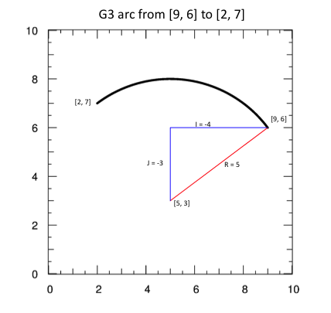

Figure 2.5 – parameters of G3 command

The RS-274 standard specifies the G-code format. Any input not explicitly allowed is illegal and will cause the Interpreter to signal an error. Spaces and tabs are allowed anywhere on a line of code and do not change the meaning of the line, except inside comments. This makes some strange-looking input legal. The line “g0x +0. 1234y 7” is equivalent to “g0 x+0.1234 y7”, for example. Blank lines are allowed in the input. They are to be ignored. Input is case insensitive, except in comments, i.e., any letter outside a comment may be in upper or lower case without changing the meaning of a line.

The difference is that the equal (=) sign is used in ISO 6983 . A block of data shall consist of the sequence number word and the data word. The preparatory words “G” or “M”. The dimension words, which shall be arranged in the following sequence: X, Y, Z, U, V. The rate at which the controlled point or the axes move is nominally a steady rate which may be set by the user. In the Interpreter, the interpretation of the feed rate is as follows unless inverse time feed rate mode is being used in the RS274/NGC view.

## Current method of planning trajectory

The difference between path and trajectory is pointed out by (Hlaváč, n.d.) where the path provides a pure geometric description of motion and trajectory can be regarded as a path plus velocity and acceleration. According to (Craig, 2005) trajectory is described as the desired motion of a manipulator in multidimensional space, and in robot design it refers to a time history of position, velocity, and acceleration for each degree of freedom.

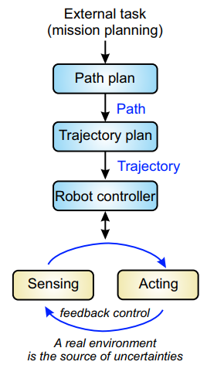

Figure 2.6.1 – flow chart of planning robot trajectory

### Joint scheme and Cartesian scheme

Generally, there are two schemes to generate path. Joint scheme is to describe the path shapes in terms of functions of joint angles. Each path point is usually specified in terms of a desired position and orientation of the tool frame, {T}, relative to the station frame, {S}. Each of these via points is "converted" into a set of desired joint angles by application of the inverse kinematics. Then a smooth function is found for each of the n joints that pass through the via points and end at the goal point.

The joint scheme is widely used in serial robots not only they are driven by the joint motors but also the problem of singularity. The Cartesian scheme is much easy to understand, however, Cartesian schemes are more computationally expensive to execute, because, at run time, inverse kinematics must be solved at the path-update rate—that is, after the path is generated in Cartesian space, as a last step the inverse kinematic calculation is performed to calculate desired joint angles.

### Bresenham’s algorithm

The path is a set of coordinates that described not only by a desired destination but also by some intermediate locations, or via points, through which the manipulator must pass enroute to the destination. When a G-code command is interpreted, a path is then generated. The criteria of evaluating path is smooth, however, the path cannot be as smooth as theoretically because of the motor properties which means the smooth path have to be approximated. The solution in GRBL is to used Bresenham's line algorithm to approximate a straight line into a set of points (Skogsrud, 2009).

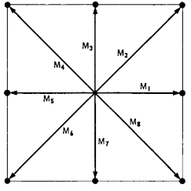

Figure 2.6.2 – eight linear movements

Bresnham’s algorithm is commonly used on digital computers as a digital plotter (Bresenham, 1965). The fundamental idea is to simplified any of the motions into eight linear movements shown in figure 2.6.2. meanwhile the lengths of movements are determined by the resolution.

In most cases, the ideal path will pass between any of the two directions, then the question becomes to determine which standard movement is closer to the ideal one. For example, two adjacent data points $D_{1}$ and $D_{2}$ is shown in figure 2.6.3, since point $Q$ is closer to the ideal path than $R$, vector $D_{1}Q$ is chosen as the next movement.

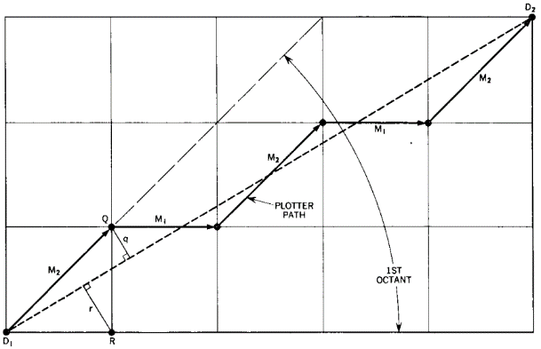

Figure 2.6.3 – Bresenham’s algorithm

## Current Method of Solving Kinematics problem

The kinematics problem of a linear delta robot can be divided into two parts the inverse kinematics (IK) and forward kinematics (FK) (Craig, 2005). IK problem is to convert the cartesian coordinate to the position of linear actuator, otherwise FK problem is to convert the linear actuator position to end effector position.

### Inverse Kinematics

The Inverse kinematics problem of a linear delta robot is simple, which can be presented as a polynomial (Stock & Miller, 2003);(Liu, et al., 2003). A general method is to find a loop-closure of each limb that is holding with respect to the base and a typical inverse kinematics equation can be presented as equation (1).

|  |  |
| --- | --- |
| $${\left(x-x_{i}\right)}^{2}+{\left(y-y_{i}\right)}^{2}+{\left(z-z_{i}\right)}^{2}=L^{2}$$ | (1) |

Where x, y, z is the position of the end effector with respect to the base, L is the chain length, zi is the carriage position with respect to the base, and xi and yi are determined by the distance of each tower to the origin point and the shape of end effector.

### Jacobian Matrix

The Jacobian matrix is defined as the matrix that maps the relation between the velocity of the moving platform and the actuated joint rates (Stock & Miller, 2003). A typical Jacobian matrix can be presented as equation (2).

|  |  |
| --- | --- |
| $$\dot{ρ}=J\dot{p}$$ | (2) |

Where $\dot{ρ}$ is the vector of end effector velocities and $\dot{ρ}$ is the vector of carriage velocities and $J$ is the Jacobian matrix. The Jacobian matrix can only be defined after the inverse kinematics equation is applied.

### Forward kinematics

Calculating FK in terms of polynomial has been proved by many researches such as (Liu, et al., 2003) and (Yuan, et al., 2008). It can also be applied with numerical method. However, FK problem is hard to solve directly, because the process is to solve ternary quadratic equations. Figure 2.7 is the simulation result with Matlab by (Rodriguez & Jaimes, 2019).

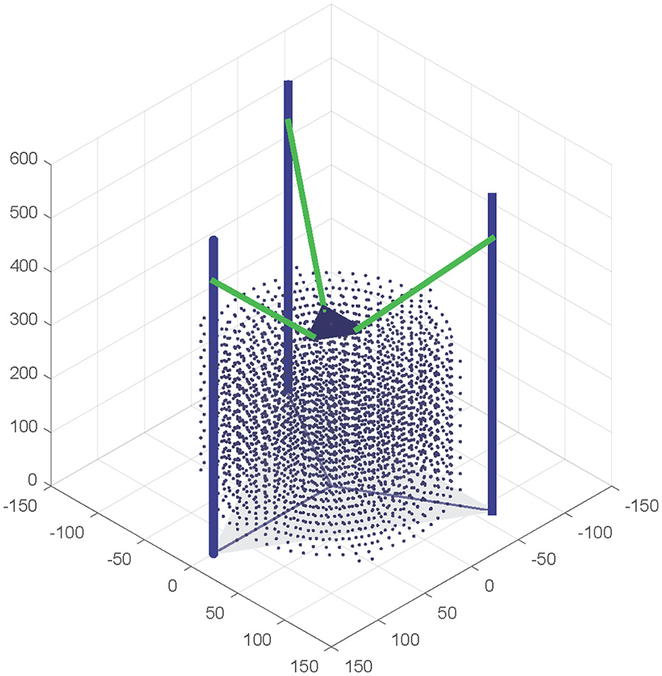

Figure 2.7 – FK simulation with Matlab

The purpose of solving forward kinematics in Marlin firmware is to initialize the coordinate system and update the information that presented on LCD panel. The method of calculating FK in Marlin firmware is called trilateration (Zalm, 2011). The principle is that the coordinate of a point can be determined if its distance to other three certain points is curtained. This algorithm is also mentioned in (Rodriguez & Jaimes, 2019), in which the model can be represented as the intersection of three spheres as illustrated in Figure 2.8. The centers of the spheres Qi are not the position of carriages but the offsets xi,yi,zi in equation (1). The intersections point P is the geometry center of the end effector, and the lengths between Qi and P are the same which is the length of mechanism chain.

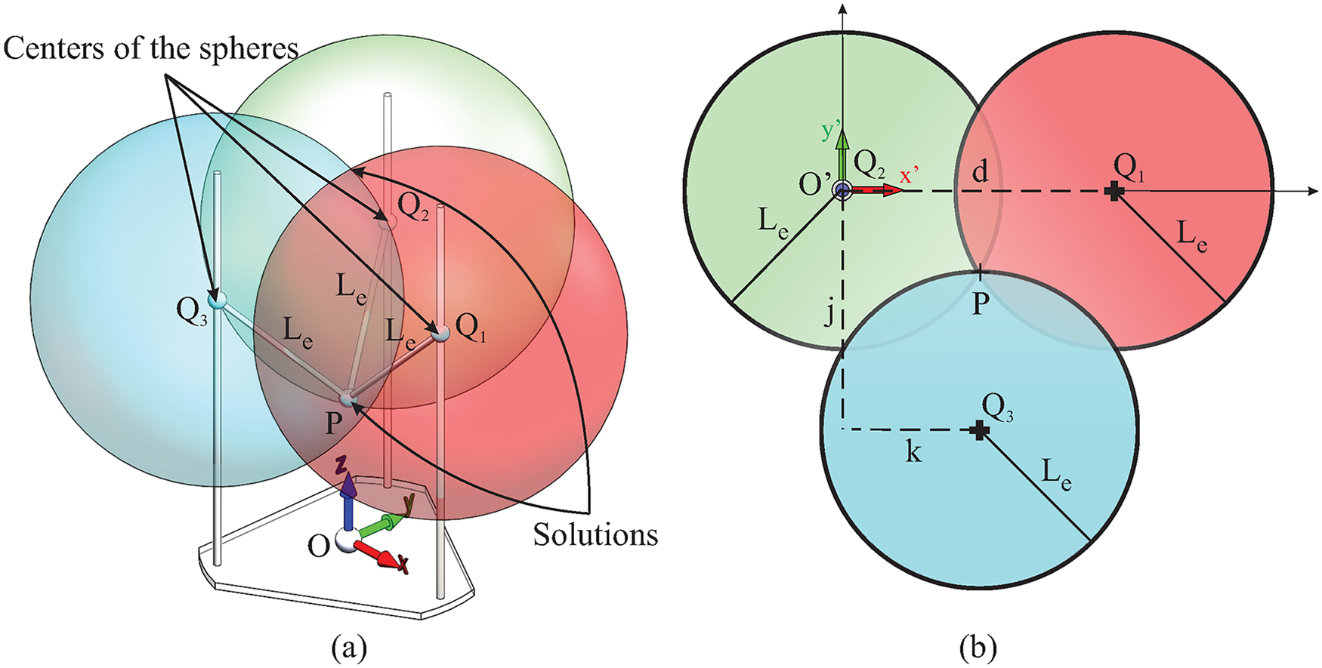

Figure 2.8 – model of solving FK with trilateration

## Current stepper motor control algorithm

The trajectory is expected to be smooth, because rough, jerky motions tend to cause increased wear on the mechanism and cause vibrations by exciting resonances in the manipulator. A smooth function is defined as a function that is continuous and has a continuous first derivative (Craig, 2005). Generally, there are two schemes to make the trajectory smooth, one is s-cure profile and another is trapezoidal-curve profile.

### S- curve profile

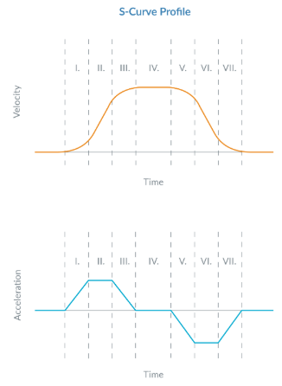

### Trapezoidal-curve profile

Most of the designs such as those are listed in table XXX are equipped with NEMA 17 stepper motors without encoders, which means the control system is open looped, and a proper motor driving algorithm should be designed. Moreover, with the application of motor driver chips such as A4988 which has been mentioned before, the output of the controller is in forms of impulse. However, there is still a problem which is the impulse-time diagram does not match the velocity-time diagram.

This problem is analyzed by (Stoychitch, 2018), and according to his research, the algorithm includes two parts: trajectory planning and pulses generating. The first step is to distinguish whether the motion is trapezoidal or triangular. Trapezoidal motion includes an acceleration part, a constant velocity part and a deceleration part, while the triangular motion has no constant velocity part. The triangular may occur when the total steps required is not enough for accelerating to meet the maximum velocity.

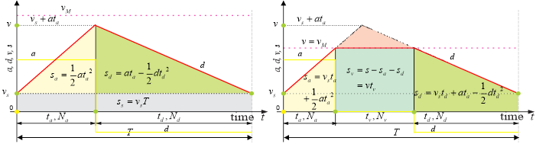

Figure XXX (A) – triangular motion

Figure XXX (B) – trapezoidal motion

According to XXX’s idea, the proportion between the steps amount in each section should be the same as it between the corresponding areas. At the same time, another problem comes which is the areas can be presented in terms of float or double precision float, but the step amount can only be presented in integer. In order to minimize the effect of losing the decimal part, steps for constant velocity motion should be first determined, and steps for acceleration should be determined after the deceleration steps are considered.

There are to schemes to design the pulse generating algorithm, one is the “time per step” schemes, another is the “steps per time” scheme. It has been proved that the “time per step” scheme is much suitable on processors, especially those with floating-point unit (FPU), while another one is suitable for FPGA. The purpose of the “time per step” scheme is to determine the time delay between two impulses which is shown in figure XXX.

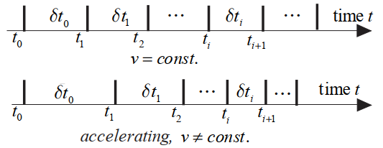

Figure XXX – the “time per step” scheme

## Stepper motor theory

It is necessary to research on features and performance on current stepper motor and motor drivers, so that the maximum speed and acceleration can be determined.

### Stepper motor torque

Pull-in Torque – the amount of torque in which the motor may move the load without acceleration. Generally older catalogs showed the Pull-in torque-speed curve to show the speeds at which the motor may start, stop and reverse without losing synchronicity with the incoming pulses.

Pull-out Torque – the amount of torque the motor may dynamically produce at various speeds. Generally this is the torque-speed curve. If the motor exceeds this torque it loses synchronicity with the incoming pulses and stalls.

Holding Torque – the amount of external torque which must be exerted on the shaft motor when the motor is at full rated current and is at rest (zero speed). This is the static torque and is not on the torque speed curve. It is generally about 20% higher then the low speed torque of the dynamic torque-speed curve.

Detent Torque – the amount of torque the motor produces when not energized. No current is flowing through the winding and the motor is at rest.

Pull-in Torque was generally used due to the motor not being capable of running through the low end resonance region. With the advancement to Microstepping, we no longer need to start and stop from a pre-determined speed without the fear of losing synchronicity with the incoming pulses and stalling.

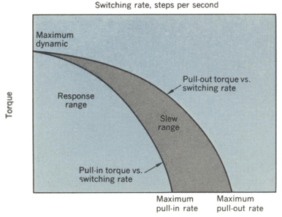

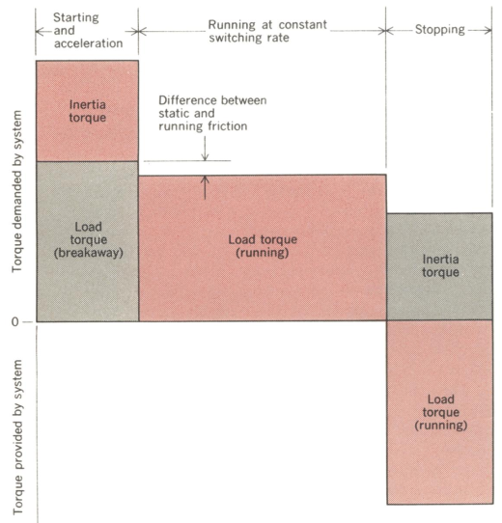

Stepper motor pullout torque is the highest torque a stepper motor can output at a given speed without losing steps. Manufacturers find a stepper motor’s pullout torque by accelerating the motor up to the target speed and then increasing the torque load until the motor starts missing steps or stalling.

Some of the stepper motor nomenclature includes some terms not often used today. Such terms are Pull-in Torque and Pull-out Torque.The information below may be helpful in understanding the different torque values for stepper motors.

Attached is an older Torque-Speed Curve illustrating Pull-in Torque (Start/Stop).

Low end resonance are typically found in the 50 – 200 steps/second (15 – 60 RPM) region.

(Warguła, et al., 2017)

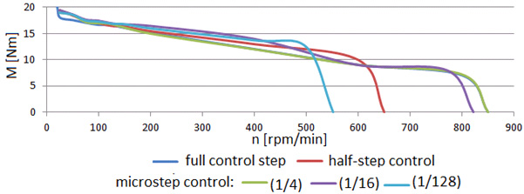

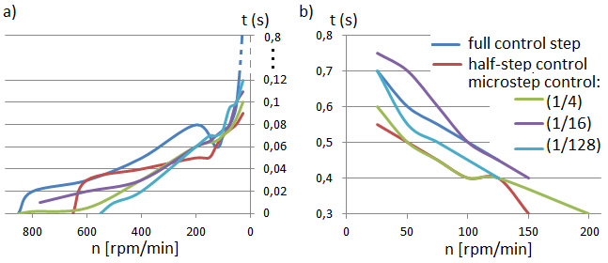

### Stepper motor driver

# Method

what apparatus (or software) was used and the way in which the experiment (or model) was set up. The method will describe how the testing was carried out and will justify the ways in which results were collected and recorded and what measures were taken in order to recognise and reduce sources of error. 6600 words

In this chapter the methods used to achieve the objectives are explained. The process of designing the robot begins with analysing the workspace which is seem as the requirement; then by study on and modify on current models a mature and conservation scheme can be determined; after that feasibility analysis will be carried on based on component limits, costs and failure mode. The control system can be designed as the mechanism is designed. A flow chart of the whole program will be given; each function will be presented in detail in both theories and programs. At the end of this part, the test scheme and test criteria will be mentioned.

## 3.1. Workspace analysis

Previous studies had already explained the general processes of analyzing the workspace of a linear delta robot, which is first defining three spheres and then add limits on it. However, in this section the analyzation begins with the joint limits, which is much closer to engineering problems. Ball joints are widely used on delta robots as the connections between rods and sliders because they can provide rotations around two perpendicular axes. However, one of the rotations is limited due to the physical structure, figure 3.1.1(a) is the drawing of a ball joint, from which the joint limit angle is labeled as 2 * w.

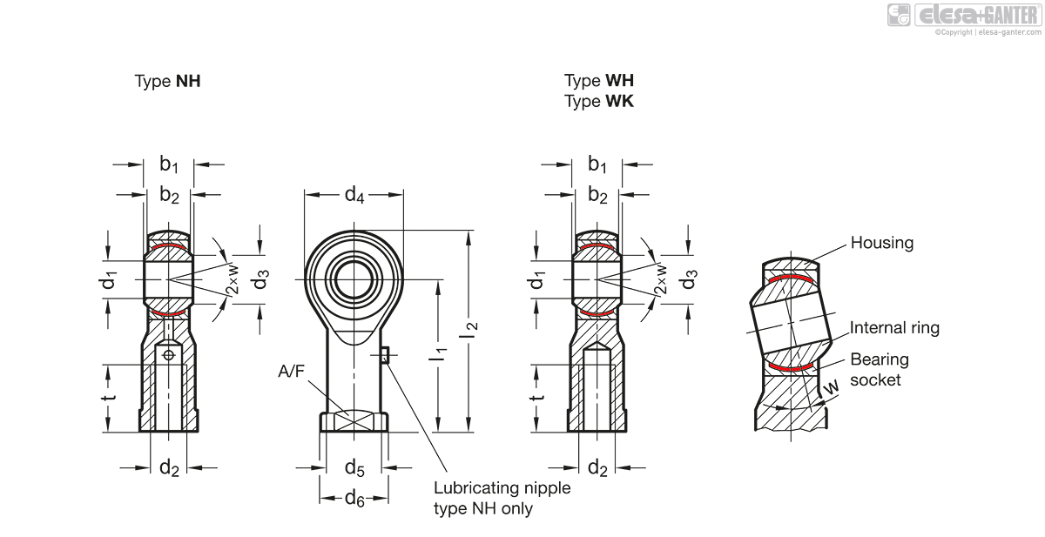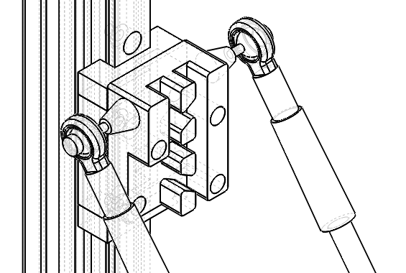

<https://www.elesa-ganter.com/en/www/Joints--Stainless-Steel-Ball-joint-heads-with-female-thread--GN6485>

Figure 3.1.1(a) – drawing of a ball joint

Figure 3.1.1(b) – application of ball joints

Suppose the unlimited rotation is around the horizontal axis, then the sketch is shown in figure 3.1.1(b). The method of analyzing the workspace is first to simplify each chain into a rod-slider system which is shown in figure xxx, the two rod AC and CB represent the edge positions that the chain can achieve, the two rods are linked to three sliders with ball joints. Slider C represents the linear actuator that can move along y axis. Slider A and slider B can move along x axis, meanwhile line AB is perpendicular to both x and y axis, because each chain is a four-bar mechanism. The area that line AB swept is the work plane, which can be calculated as:

|  |  |
| --- | --- |
| $$S=2a∙b=\frac{2{L }^{2}}{sin⁡(α)sin⁡(β)}$$ | (1) |

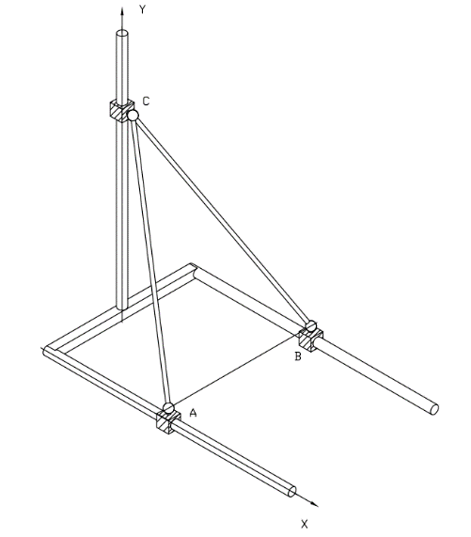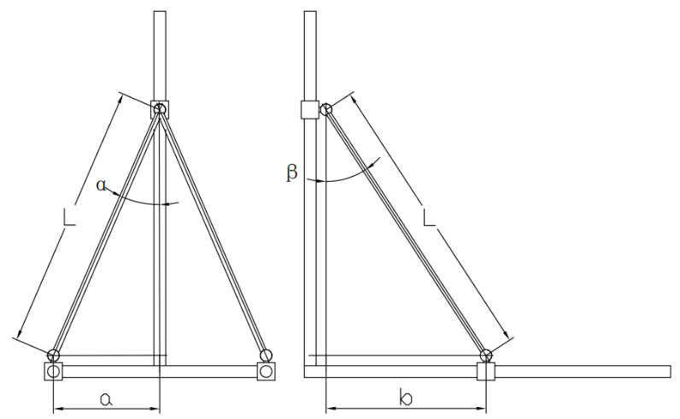

Figure 3.1.2 – workspace model

The limit angle $α$ of those ball joints that used widely on home 3D printer is about ${20}^{°}$, and the range of angle $β$ is from $0^{°}$ to ${90}^{°}$. The actual workspace of a single chain is shaded in figure 3.1.3, the arc at the end of the work plane only can be achieved when angle $β$ is nearly ${90}^{°}$. As considering the radius of the end effector the workspace translates the length of the radius along the x axis.

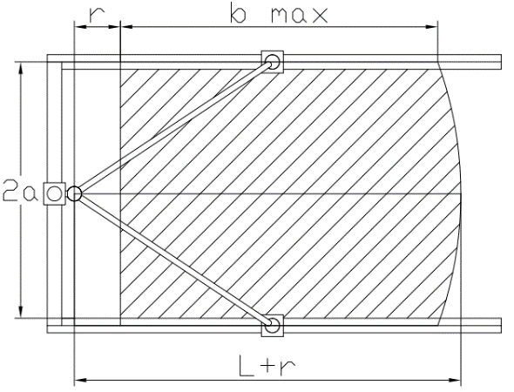

Figure 3.1.3 – model of maximizing workspace

In conclusion, the features of the workspace can be summarized as the following points

1. Rectangular shape
2. End effector radius decreases the proportion between workspace and robot size
3. Longer chains create larger workspaces

Since the workspace of a single chain can be approximated as a rectangle, then the work comes to combine these three rectangles and find the largest covered area. Theoretically, there are three types of structures; the first one is equilateral triangle structure which is used by most of commercial 3D printers, as is shown in figure XXX the angle of each two motor is 60 degree, the workspace of this kind of structure is hexagon. As a result, most of the delta 3D printers have a circle shaped hot bed. Second one is isosceles obtuse triangle structure, which is shown in figure XXX, the angle between each motors are 120 degree and 30 degrees, this structure brings the same workspace as the previous one but increases the proportion of workspace and robot size dramatically, by contract the size of end effector increases in the same proportion. The third one is Isosceles right triangle structure which is shown in figure XXX, this structure can be regarded as a compromise solution of the previous schemes. The structure brings a square workspace, and half of it is outside the robot.

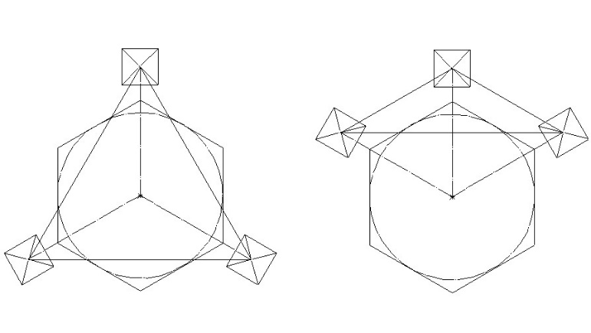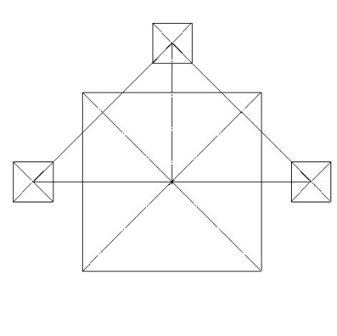

Figure 3.1.4 (a) - Equilateral triangle structure

Figure 3.1.4(b) - Obtuse triangle structure

Figure 3.14(c) - Isosceles right triangle structure

The forth structure which has been built by XXX is to let the limited rotation around the horizontal axis, which is shown in figure xxx, where $α$ is the joint limit angle, $θ$ is the offset angle, and $S$ is the width of the workspace concentric circles.

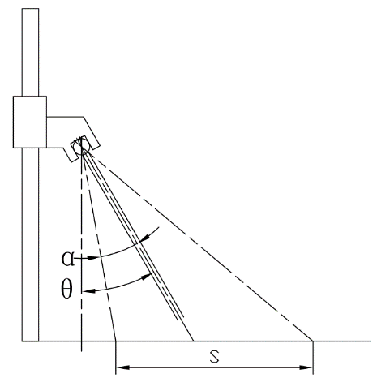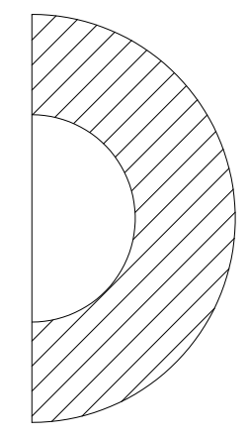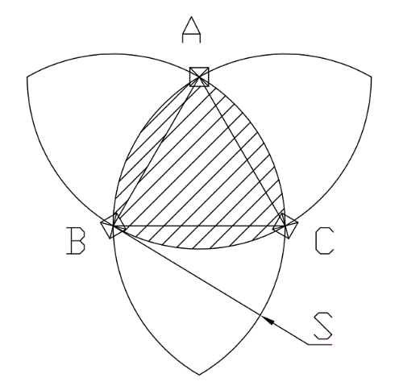

Figure 3.1.5 – forth scheme

The expression of distance S can be written as:

|  |  |
| --- | --- |
| $$S=\left[\sin\left(θ+α\right)-tan⁡(θ-α)∙cos⁡(θ+α)\right]∙L$$ | (2) |

Where L is a constant.

|  |  |
| --- | --- |
| $$p=\frac{tan⁡(θ+α)}{tan⁡(θ-α)}-1$$ | (3) |

The equation has a lowest solution. In other word let p = 0 is the optimized solution, and the equation can be presented:

|  |  |
| --- | --- |
| $$s=sin⁡(2α)∙L$$ | (4) |

In conclusion, the scheme that is shown in figure XXX will be applied, not only square workspaces are more common in daily life such as paper and sheet material, but also a balance between innovations and design maturity.

## Robot Design

The first model designed is based on the Kossel linear plus 3D printer, which is shown in figure XXX. The robot has a square workspace of 180mm*180mm but reserved almost all the features on the origin product. The three motors are placed at the bottom, and another plane is needed to cover over the motors, such design provides a stable structure and lower center of gravity.

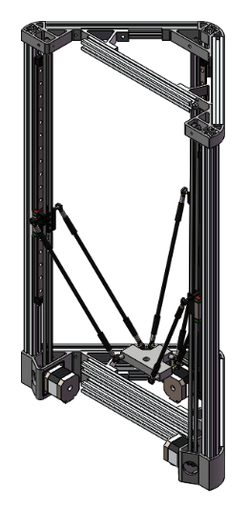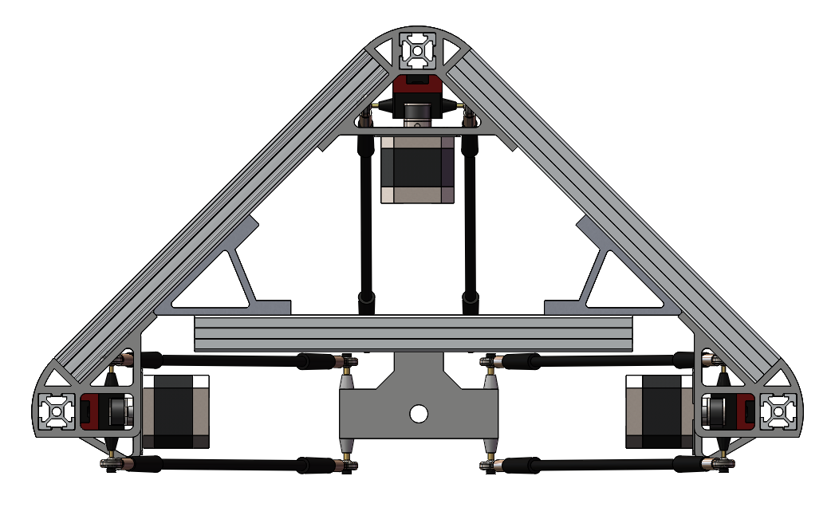

Figure 3.2.1 – the first design

The transmission system uses of timing belts to actuate robot carriages vertically along a linear rod/rail as shown in Figure 13. The stepper motor is NEMA 17 which is a two phase variable-reluctance stepper motor, the drawing of the 2GT timing belt and belt pully is shown in figure XXX. The diameter is 13mm, as a result the length of each step can be calculated:

$$l=θ∙r$$

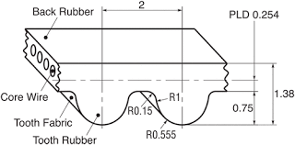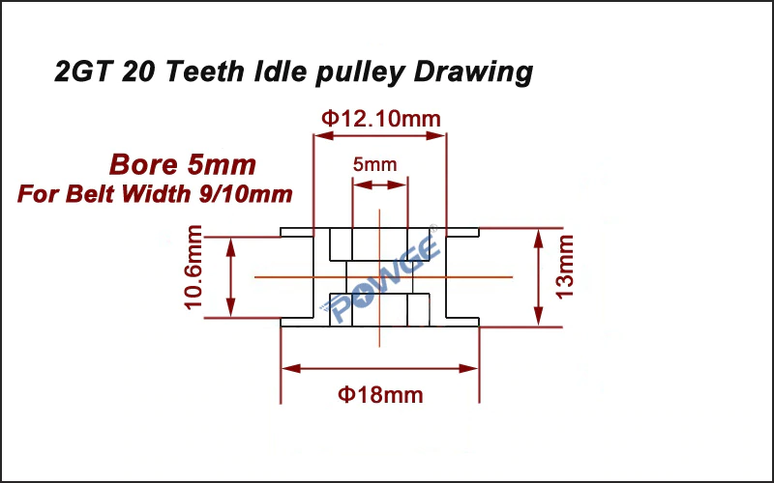

Figure 3.2.2 (a) – 2GT timing belt

Figure 3.2.2(b) – 2GT pully

The structure of the origin design is made up of 2020 aluminum extrusions and injection mold joints, and the joints also work as motor frames. Figure 3.2.3(a) shows an injection mold joints of Kossel printer, the joint provides a 60-degree angle, the extrusion can be fixed through the square hole. The parts are assembled with m4 hex bolts, the advantage of using hex bolts is that hex keys are often design to operate in tiny space.

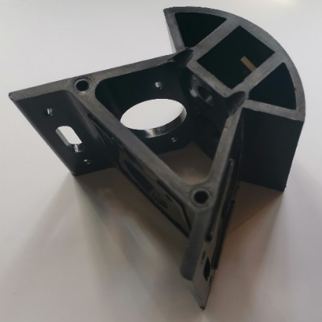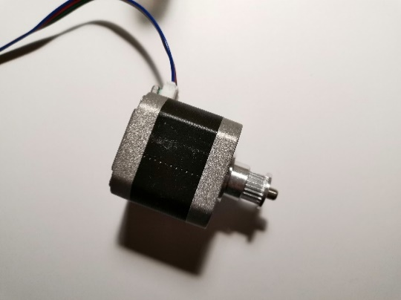

Figure 3.2.3 (a) – joint of Kossel Linear plus 3D printer

Figure 3.2.3 (b) – NEMA 17 stepper motor

In order to fit the new workspace, the joints are modified and shown in figure 3.2.4. Only one side of two of the joints are connected to the extrusion, another one provides 90 degree angle. Since FDM decreases material properties, these parts will only work as the motor frame, besides 6 metal joints are added on the frame.

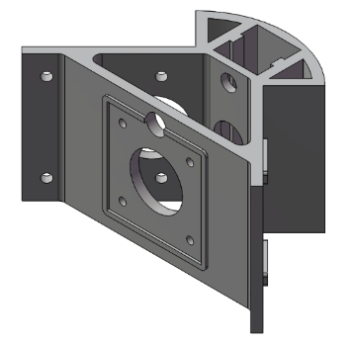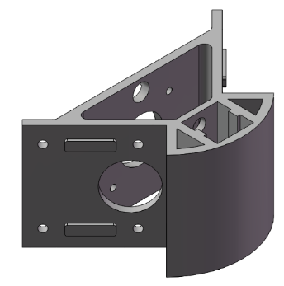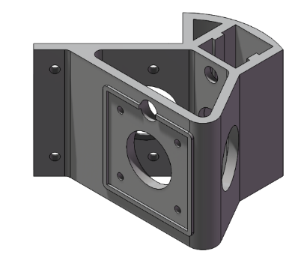

Figure 3.2.4 – new designed joint

The most unique designed part of the original design is the carriage. The shape of the carriage is designed to fix the belt, which is shown in figure XXX. The carriage is fixed on the linear guide, at the top of the guide a limit switch is fixed. The switch needs a long wire.

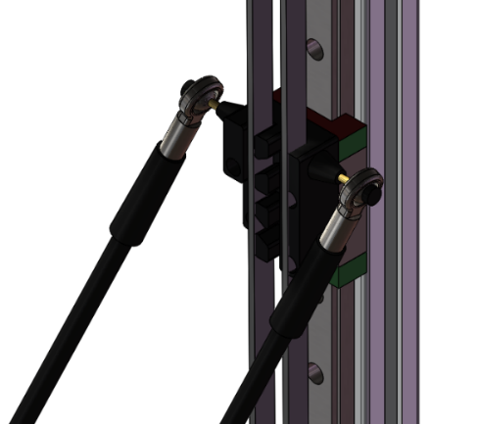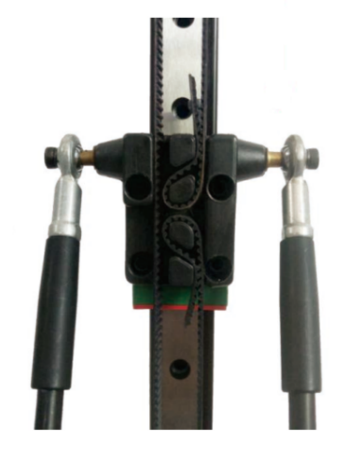

Figure 3.2.5(a) – carriage of first design

Figure 3.2.5(b) – carriage of Kossel Linear plus 3D printer

The drawback of the design is obvious too, the belt interference. The interference occurs when

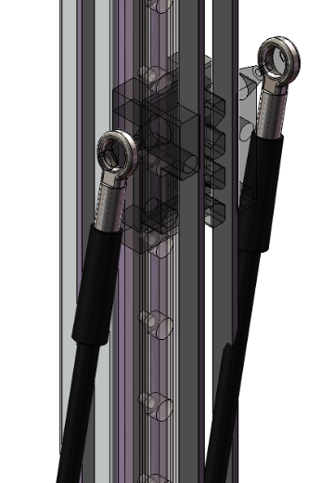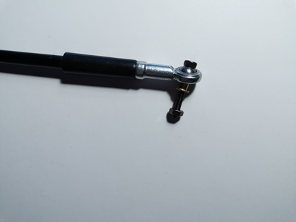

Figure XXX(a) – belt interference

Figure XXX(b) – rod terminal

### Alternative design

The second design is aimed to solve all the problems raised above. First of all, as considering the demand, the working plane must coincide with the mounting plane of the robot. As a result, the circuit and microcontroller have to be placed at the top, in order to reduce wire waste, it is a good idea to place the stepper at the top too. Then is the interference problem, one solution to entirely avoid belt interference is to add an offset between the ball joint and carriage

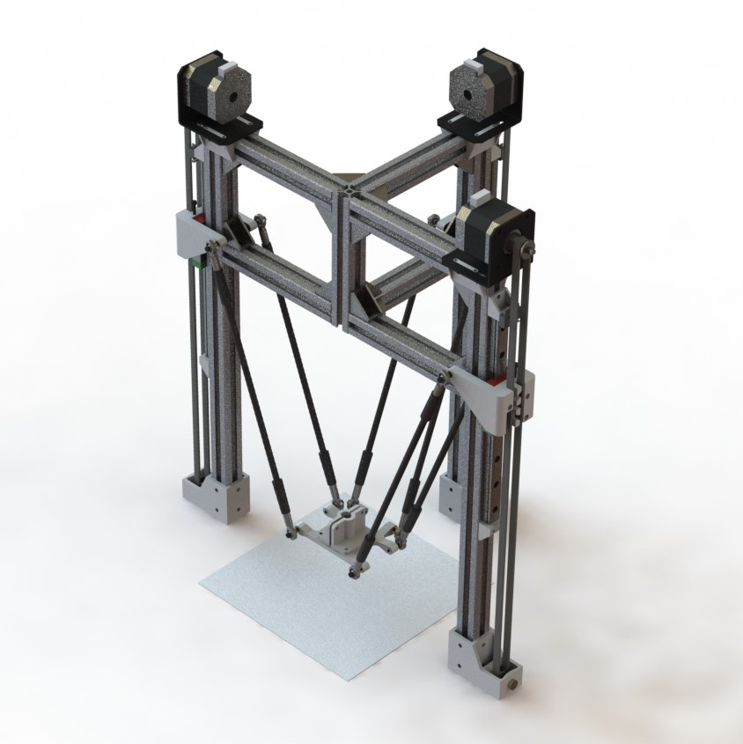

### Structure

The structure is consisted of aluminium extrusions and 90-degree aluminium joints which solved

The new design is shown in figure XXX, in this design the timing belt and carriage joint are placed at both sides of the tower and the motor is placed at the top of each tower. The maximum shift angle of each joint is 20 degree, the chain length is 264mm to achieve a 180mm * 180mm square work space. As is shown in figure XXX, D represents the distance between tower center line to end effector center line. In the new design the chain can be vertical when D is at its minimum.

θ

R = 130mm

r = 40mm

L = 264mm

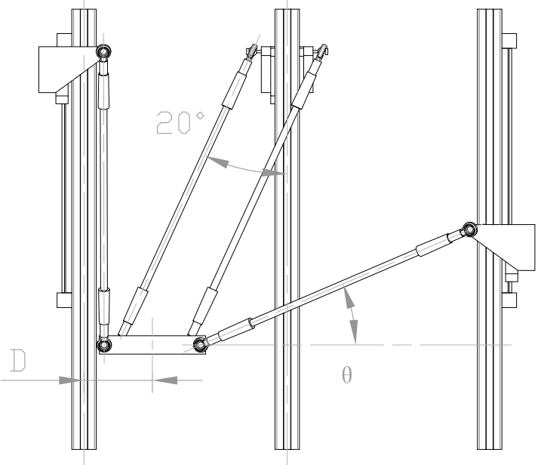

### Motor frame

The stepper motor is designed at the top of the tower, so that the weight can be transferred directly. Figure XXX is the model of motor frame

Not only stiffener but also the base of FDM

### Carriage

M2.5 bolt

6mm ball

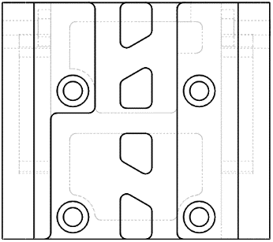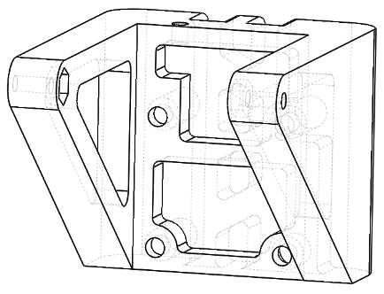

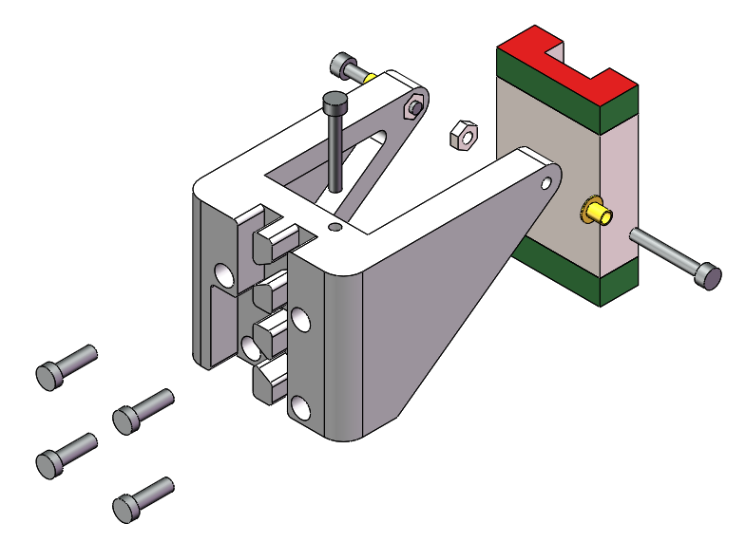

Figure XXX – explore figure of carriage assembly

### End effector

As is shown in figure XXX, the main part of the end effector is a. The minimum thickness of the part is designed to be 3mm.

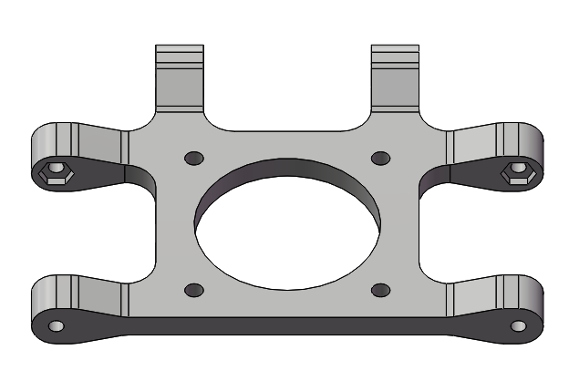

Figure XXX – end effector part

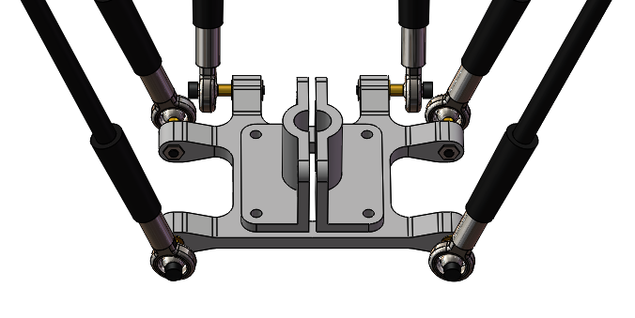

Figure XXX – end effector assembly

## Control Method

The control system includes three tasks and several interrupts, since there is no complex priority between the tasks, a typical foreground / background system which a super loop can be applied in the main function rather than using RTOS (real time operation system). The following paragraph will explain the operation process and the function of each module briefly.

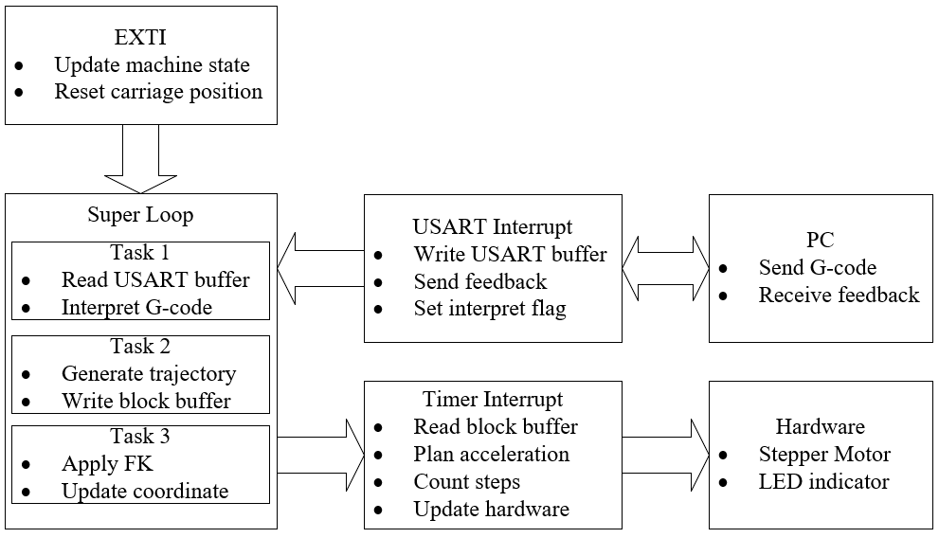

Figure 3.4.1 – Control system fundamental

The G-code command is sent from a GUI (graphic user interface) that runs on a PC through the serial port. The GUI is not a part of the design and is quote from XXX, it has the function of sending and receiving characters in the terms of Ascii codes. When the microcontroller receives data bits from the port the USART interrupt function will save these data into a circular buffer and then set the interpret flag.

Interpreting G-code is the first task in the super loop, which will be executed if the interpret flag is set and the details about the interpretation will be explained in section 3.4.2. After interpretation, the second task will be executed to generate a trajectory, in which the path generation, kinematics conversion and block generation will be applied. The third task is seemed as a feedback task, in which forward kinematics will be applied to update the end effector position.

The timer interrupt which works as a monitor has the second higher priority, the timer interrupt function is executed periodicily begin with reading a block from the block buffer, then plan the acceleration and deceleration steps. The external interrupt has the highest priority which can be triggered by limit switch and stop and reset button. It also works for insurance.

### Serial Communication

In this section, method of using serial communication to receive and send information on STM32 will be explained. However, the algorithm in programming will not be focused, because the serial lib provided by Alientek has already optimized and meet the demand. Fortunately, a protocol chip is embedded on the board, which convert RS232 to micro USB. So, the only job needs to do is to connect TX and RX terminal with two GPIOs which is shown in figure 3.4.2.

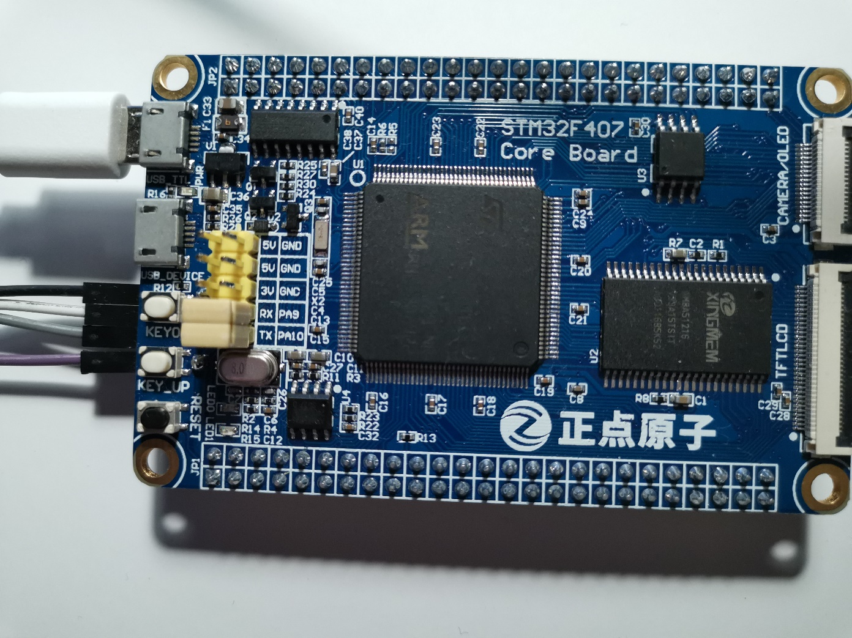

Figure 3.4.2 – serial port

The following piece of codes is the USART interrupt service routines which will be executed automatically as soon as USART1 port receives data. The first step is to check and reset the interrupt pending bit; then the character that received from the serial port will be saved in a temp variable “res”; after that the temp

void **USART1_IRQHandler**(void)

{

    uint8_t res;

    if (**USART_GetITStatus**(USART1, USART_IT_RXNE)!=RESET)

    {

**USART_ClearITPendingBit**(USART1, USART_IT_RXNE);

        res = **USART_ReceiveData**(USART1);

**Uart_Buff_Write**(&uart_buff,res);

        if (res==13)    machine.interpret_flag = SET;

    }

}

The USART buffer is designed as a circular buffer, which is shown in figure 3.4.2. Circular buffer is a type of FIFO (first in first out) data structure, which can be presented as a array with a constant length and two pointers. The head pointer points to the value that will be read first, and the tail pointer points to the position that a new value will be wrote. When a value is read from the buffer, the head pointer points to the next address which means the read value will not be cleared but will be covered automatically when

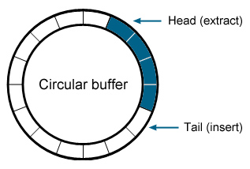

Figure 3.4.2 – Circular buffer

The advantage of using the circular buffer is that its memory is continuous, which increases the reading speed. Moreover, a structure is designed to put the array, pointers and buffer length together which is shown in the following code.

typedef struct

{

    uint16_t    head;

    uint16_t    tail;

    uint16_t    length;

    uint8_t     content[100];

}**uart_buff_t**;

### G-code Interpreter

The G-code interpreter is used to call proper functions for different command. When the carriage return character which can be presented as 13 in integer is detected, the g-code interpreter function will be called. Figure XXX is a flow chart of the interpreting and writing linked list.

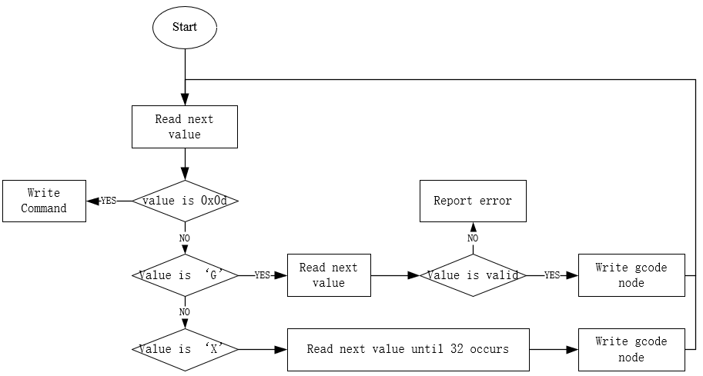

Figure 3.4.3 – flow chart of interpreter

|  |  |  |
| --- | --- | --- |
| Command | Function | Parameters |
| G0 orG1 | Linear movement | Target coordinate, nominal velocity |
| G2 or G3 | Arc movement | Target coordinate, center offset |
| G4 | Dwell | Dwell time in seconds |
| G28 | Auto home | None |

Each node includes xyz coordinate, operation federate and command type. As considering reducing memory usage, arc motion radius and dwell time shares a single variable, when the command type is dwell, then the variable will be considers as dwell time, otherwise it will be regarded as arc radius. The radius is positive in G2 command and negative in G3 command.

typedef struct **_command**

{

    float xyz[3];

    float feedrate;

    float radius_dwell;

    uint8_t type;

}**command_t**;

enum **Motion_Type**

{home_t = 0, linear_t, arc_t, dwell_t};

An important function of the interpreter is to get the float values from a char array. The function starts with reading a value from the buffer and end with detecting an un-number value.

float **Uart_Buff_Read_Num**(uart_buff_t* uart_buff)

{

    uint8_t value;

    uint8_t sign = 0;

    float result = 0.0f;

    value = **Uart_Buff_Read**(uart_buff);

    if (value=='-')

    {

        sign = 1;

        value = **Uart_Buff_Read**(uart_buff);

    }

    for (value;value<='0'||value>='9';value = **Uart_Buff_Read**(uart_buff)

    {

        result = result*10.0f+**Ascii**(value);

    }

    if (value == '.')

    {

        value = **Uart_Buff_Read**(uart_buff);

        for (float i = 1.0f;value<='0'||value>='9';value = **Uart_Buff_Read**(uart_buff))

        {

            result = result + **Ascii**(value)\***E**(i);

            i = i - 1.0f;

        }

    }

    if (sign == 1) result = -result;

    return result;

}

### Kinematics problems

The method of solving inverse kinematics is based on XXX’s research.

$${[p_{i}]}_{R}={(DEOcosη_{i} DEOsinη_{i} 0)}^{T}$$

$${[b_{i}]}_{R}={(Rcosη_{i} Rsinη_{i} z_{i})}^{T}$$

$$\left\|{\left[p_{i}-b_{i}\right]}_{R}\right\|=L$$

$${(x-x_{i})}^{2}+{(y-y_{i})}^{2}+{(z-z_{i})}^{2}=L^{2}$$

|  |  |
| --- | --- |
| $$\sqrt{{L^{2}-(y-y_{i})}^{2}-{\left(x-x_{i}\right)}^{2}}+z=z_{i}$$ |  |

In which, $x_{i}=(DSRO-DCO-DEO)cosη_{i}$, $y_{i}=(DSRO-DCO-DEO)sinη_{i}$, $z_{i}$ are the inputs, the position of the carriages.

Solving forward kinematics problem is to find the end effector coordinates when the carriages positions are defined, theoretically the solutions can be found by solving Ternary quadratic equations:

|  |  |
| --- | --- |
|  |  |

|  |  |
| --- | --- |
|  |  |

However, such method is not suitable for numerical methods. Here is an experiment to test execution time of solving ternary quadratic equations on Matlab. The step length of each linear actuator is set to 10mm and the motion limit is from 250mm above ground to 500mm, as is shown in figure XXX, 27001 points are plotted and the time consumption is 4.75 hours. It is straight forward to work out that it takes 0.63 second on each point on the path.

The second method is trilateration which has been introduced in section XXX. As is shown in figure XXX, the three carriages are labelled as $Z_{1}, Z_{2} and Z_{3}$, E represents the end effector, and E’ is the projection of point E on plane $Z_{1}Z_{2}Z_{3}$. The problem is to find the coordinate of point E or vector $\overset{⃑}{OE}$ in the old coordinate system, when the coordinates of point $Z_{1}, Z_{2} and Z_{3}$ in the old coordinate system is given, the distances from point E to the carriages are known.

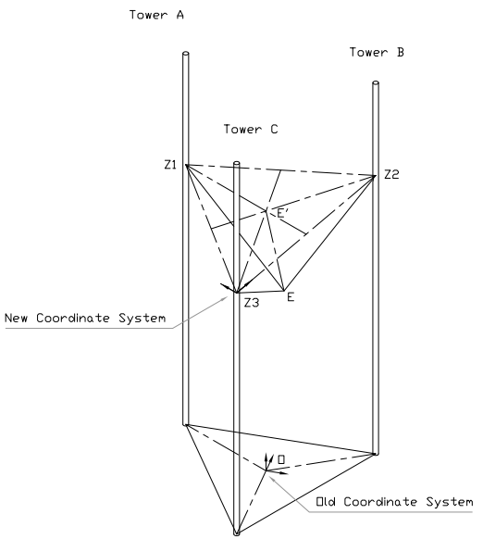

The method is to establish a new coordinate system in the plane of the three carriage points., which has its origin at tower C, with tower B on the X’ axis. Tower C is in the X’-Y’ plane with a Z component of zero. Then apply trilateration method to find $\overset{⃑}{Z_{3}E}$ which is the vector of point E according to the new coordinate system. Finally, vector $\overset{⃑}{OE}$ can be determined by applying the following calculation

|  |  |
| --- | --- |
| $$\overset{⃑}{OE}=\overset{⃑}{OZ_{3}}+\overset{⃑}{Z_{3}E}$$ |  |

The new coordinate system is shown in figure XXX. Assume point E’ is the focus of three circles, then radius of the circles can be presented as:

|  |  |
| --- | --- |
| $${r_{1}}^{2}={x_{E'}}^{2}+{y_{E'}}^{2}$$ |  |
| $${r_{2}}^{2}={(x_{E'}-d)}^{2}+{y_{E'}}^{2}$$ |  |
| $${r_{3}}^{2}={(x_{E'}-i)}^{2}+{(y_{E'}-j)}^{2}$$ |  |

As is mentioned in part XXX, $r_{1}=r_{2}=r_{3}=DDR$, and vector $\overset{⃑}{Z_{3}E}$ in the new coordinate system can be determined:

|  |  |
| --- | --- |
| $$x_{E'}={(r_{1}}^{2}-{r_{2}}^{2}+d^{2}) / 2d$$ |  |
| $$y_{E'}=\left({r_{1}}^{2}-{r_{3}}^{2}-{x_{E'}}^{2}+{\left(x_{E'}-i\right)}^{2}+j^{2}\right) / 2j$$ |  |
| $$z_{E'}=\sqrt{{x_{E'}}^{2}+{y_{E'}}^{2}+{r_{3}}^{2}}$$ |  |

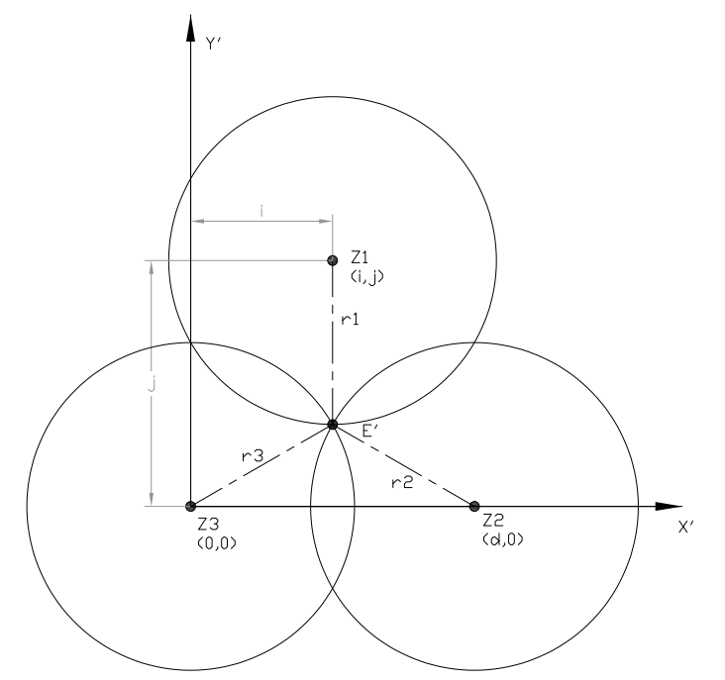

Figure XXX -

Then, the problem becomes to determine the value of $i$, $j$, $d$ and vector $\overset{⃑}{Z_{3}E}$. By creating a vector in old coordinates along x‘ axis of new coordinate.

$$\overset{⃑}{Z_{3}Z_{2}}={(x_{2}-x_{3},y_{2}-y_{3},z_{2}-z_{3})}^{T}$$

D can be determined by getting the reciprocal of Magnitude of vector:

$$d=\left|\overset{⃑}{Z_{3}Z_{2}}\right|=\sqrt{{(x_{2}-x_{3})}^{2}+{(y_{2}-y_{3})}^{2}+{(z_{2}-z_{3})}^{2}}$$

Create unit vector by multiplying by the inverse of the magnitude.

$$\overset{⃑}{X'}=\frac{\overset{⃑}{Z_{3}Z_{2}}}{\left|\overset{⃑}{Z_{3}Z_{2}}\right|}={(\frac{x_{2}-x_{3}}{d},\frac{y_{2}-y_{3}}{d},\frac{z_{2}-z_{3}}{d})}^{T}$$

Get the vector from the origin of the new system to the tower 1.

$$\overset{⃑}{Z_{3}Z_{1}}={(x_{1}-x_{3},y_{1}-y_{3},z_{1}-z_{3})}^{T}$$

Use the dot product to find the component of this vector on the X axis.

$$i=\overset{⃑}{Z_{3}Z_{1}}∙\overset{⃑}{X^{'}}$$

Create a vector along the x axis that represents the x component of p13.

$$\overset{⃑}{i}=i∙\overset{⃑}{X^{'}}$$

Subtract the X component from the original vector leaving only Y.

$$\overset{⃑}{j}=\overset{⃑}{Z_{3}Z_{1}}-\overset{⃑}{i}$$

$$j=\left|\overset{⃑}{j}\right|$$

$$\overset{⃑}{Y'}=\frac{\overset{⃑}{j}}{j}$$

Use cross product to find z vector in the new coordinate system.

$$\overset{⃑}{Z'}=\overset{⃑}{X^{'}}×\overset{⃑}{Y'}$$

Hence, coordinate of point E’ in the x’-y’ coordinate system can be determined

$$\overset{⃑}{x_{E'}}=x_{E'}∙\overset{⃑}{X'}$$

$$\overset{⃑}{y_{E'}}=y_{E'}∙\overset{⃑}{Y'}$$

$$\overset{⃑}{z_{E'}}=z_{E'}∙\overset{⃑}{Z'}$$

$$\overset{⃑}{Z_{3}E}= \overset{⃑}{x_{E'}}+\overset{⃑}{y_{E'}}+\overset{⃑}{z_{E'}}$$

### Dynamics problems

The dynamics problems of this design focus on the how the stepper motor drives the robot, especially acceleration and deceleration.

A stepper motor should provide an output torque larger than load torque and be required to start and stop at a proper step rate against load inertia. Also, while operating the motor at a rate higher than the starting pulse rate, the rate needs to be varied within a proper acceleration time. Here are some basic formulas to help you determine the torque, inertia and acceleration/deceleration time you require of the stepper motor to fit your application.

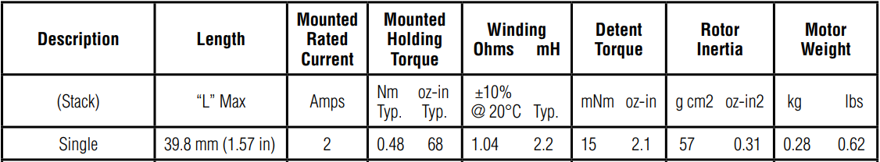

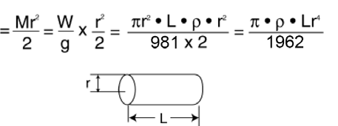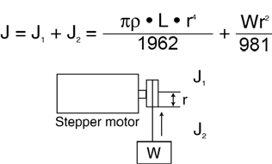

|  |  |
| --- | --- |
| $$J_{1}=\frac{Mr^{2}}{2}=\frac{W}{g}×\frac{r^{2}}{2}=\frac{πLρr^{4}}{1962}$$ |  |
| $$J=J_{1}+J_{2}=\frac{πLρr^{4}}{1962}+\frac{Wr^{2}}{981}$$ |  |

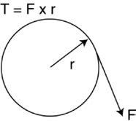

Acceleration/Deceleration Time

|  |  |
| --- | --- |
| $$t_{acc}=\frac{\left(J_{r}+J_{I}\right)*2π*(f_{h}-f_{I})}{nq*T_{a}}$$ |  |

Acceleration/Deceleration Torque

|  |  |
| --- | --- |
| $$T_{a}=\frac{\left(J_{r}+J_{I}\right)*2π*{f_{s}}^{2}}{nq*n}$$ |  |

Where

$t_{acc}=$ Acceleration time

$J_{r}=$ Rotor inertia

$J_{I}=$ Load inertia

$f_{h}=$ Slew speed

$f_{I}=$ Starting speed

$nq=$ Step/revolution

|  |  |
| --- | --- |
| $$t_{acc}=\frac{\left(f_{h}-f_{I}\right)*n}{{f_{s}}^{2}}$$ |  |

The motion of the end effector can be described with a velocity-time graph in which the acceleration carried on when the command is received till meet the target feedrate and decelerated to 0 as soon as the command is executed. However, due to the kinematics conversion the motion of each

The frequency variable

### Motion fundamental

In delta robots, the tower motion is not linear to the end effector motion. For example, assume the end effector is moving from (-90,0,0) to (90,0,0), and carriages moves in a steady velocity. The result calculated with forward kinematics is show in figure XXX, where the maximum offset is XXX. As a result, it is necessary to divide each linear segment into lots of very small subsegments (blocks).

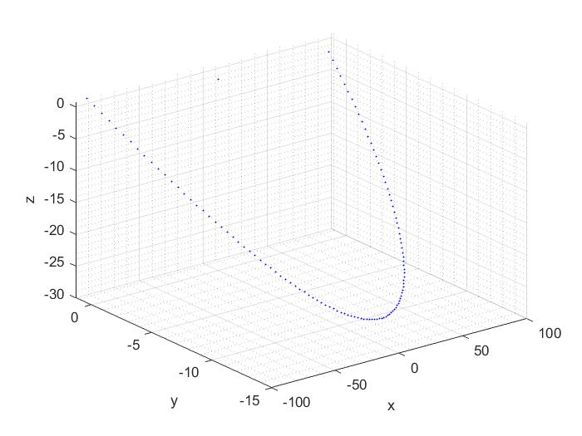

Figure XXX – path of the end effector

$$z_{i}=f\left(x\right)=\sqrt{{{DDR}^{2}-(x-x_{i})}^{2}-{\left(y-y_{i}\right)}^{2}}+z$$

The key word “block” is firstly used in GRBL firmware to describe a small segment of motion in which the motors keep a steady speed. In other words, a g-code command can be divided into a lot of blocks, of which the amount is determined by the motor resolution. The following code shown a C structure that is used this design as a block.

A block includes the direction, speed of each motor, the step count and the dwell step count; the motors start to work when the dwell step count is zero and stop when the step count is zero. The flag is used to indicate whether the it is the last block of a g-code command. The blocks are stored in a circular buffer which has the same principle with the USART buffer, because the reading speed could limit the motor update frequency.

### Linear trajectory

The idea of generating linear path is using the Bresenham’s line algorithm which is shown in figure XXX. According to the method that is mentioned in XXX, the points can be considered by comparing their distance between the ideal path, however modulus operation in C language gives another choice.

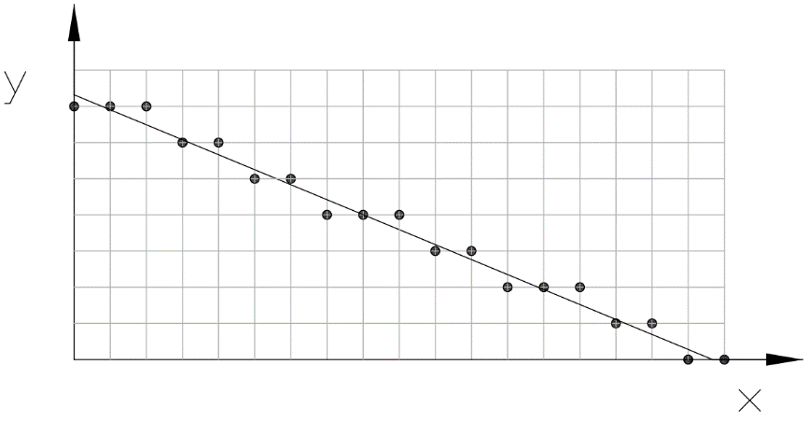

Figure XXX – Bresenham’s line algorithm

The modulus operation can be used to find the remainder of two integers. The judge statement can be written as:

|  |  |
| --- | --- |
| $$C=\frac{∆y∙x_{i}}{∆x}\%res$$ |  |

Where C is the condition

$res$ is the resolution which is the length of the matrix

$∆y$ is the y offset between initial point and target point

$∆x$ is the x offset between initial point and target point

$x_{i}$ is the sequence number of the points

As the path is same with the one shown in the picture, the y offset of next point should be minus the resolution when the remainder is smaller than half resolution. Otherwise, the y offset will not change. However, there is one drawback of using this method which is the condition of applying this algorithm is that x offset is larger than the y offset, as a result, a sorting function must be applied before generating the path.

Sub movement

|  |  |
| --- | --- |
| $$dx=res*x_{factor}$$ |  |

The input of the linear motion function includes a start point, a target point, the federate and dwell time before operation. Figure XXX is a flow chart of the function. The first

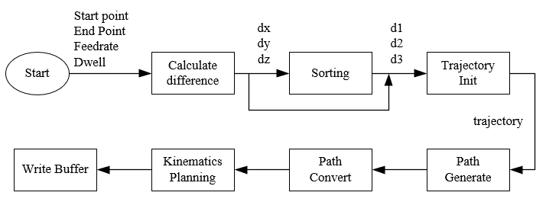

Figure 3 – flow chart of linear trajectory planning algorithm

### Arc trajectory

The method of generating arc path that is used on GRBL firmware is to divide the arc into a set of linear paths, and then generate the path with the linear path function. Such method has two drawbacks, first arc with small radius (lower than 5mm) can not be applied; second feed rate is low.

Generally, there are three methods to handle with arc motions, the Pythagorean, Polarize and Bresenham. But at the beginning, it is necessary to divide a circle into 8 sections which is shown in figure XXX, because once a point and the pivot is defined, another seven points can be found with a simple conversion. Moreover, the drawback that met in Bresenham’s line algorithm can be also solved by the way, because the derivative of the path is always smaller than 1 in the first sector.

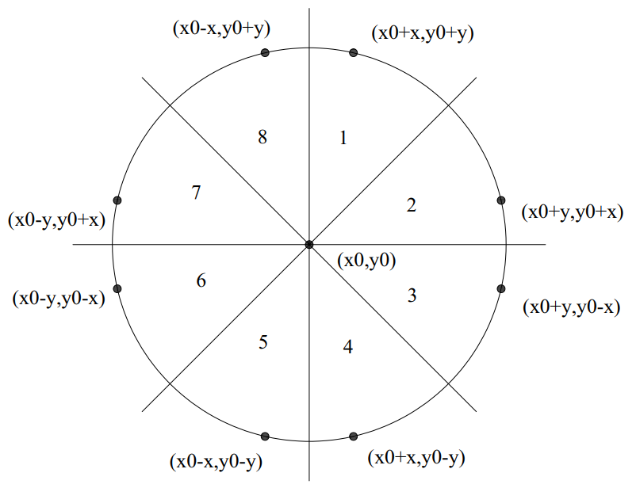

Figure XXX – Sector conversion of a circle

However, the situation that met in realistic is much complex than doing the sector conversions. As the result, the path can be classified into three cases as considering the position of the two terminal points and the arc length.

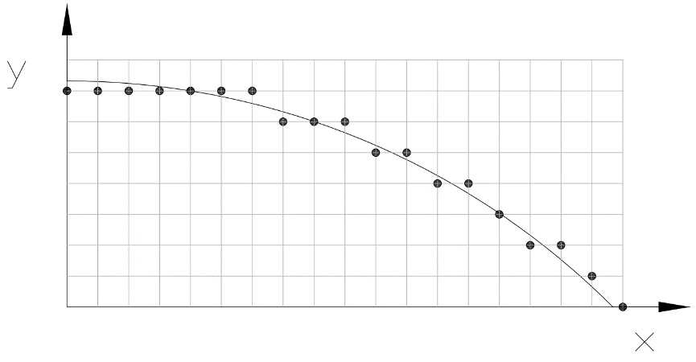

Figure XXX - Bresenham’s arc algorithm

In the first case, the path length is longer than the length of a full sector path. In such situation, at least on full sector must be covered by the path, which means the path consists a head, a body and a tail. So, the first step is to generate the full path of sector 1 and then fill in the points in body path with sector conversion. The second step is to generate the head and the tail by cutting a segment from the full sector path. The result includes three paths, but it is not necessary to do the stitch because they are continuous.

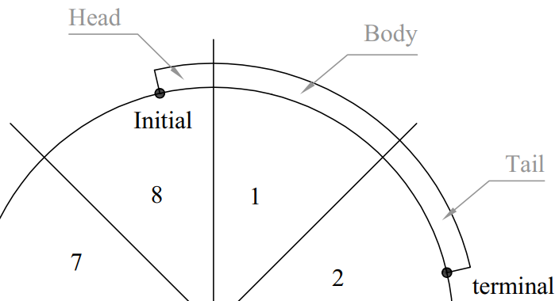

Figure XXX – Arc path in case 1

In the second case, the arc length is smaller than the length of a full sector path and both terminal points are in the same sector. In this case generating full path of a sector is inefficient or even unpractical, for example, a path with small length but large radius may waste a lot of time. Therefore, in such case the path should be generated directly.

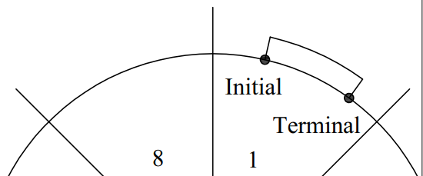

Figure XXX – Arc path in case 2

In the third case, the arc length is smaller than the length of a full sector path, but the two terminal points are located in two adjacent sectors. It is inefficient to generate both parts individually using the method that is used in case 2, because

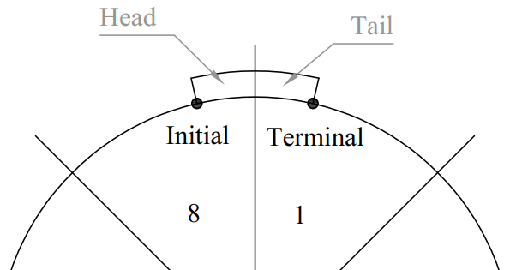

Figure XXX – Arc path in case 3

Another important method that haven’t mentioned yet is sector conversion. As is shown in figure XXX, the sequence of the points of a path is opposite between any two adjacent sectors. As a result, it is necessary to determine the sector number of the initial point and terminal point especially in case 1.

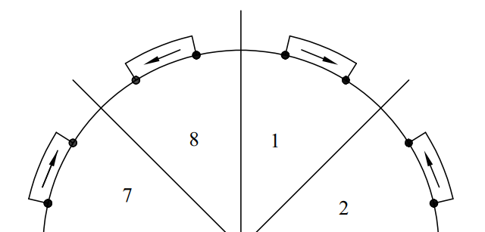

Figure XXX – Path conversion direction

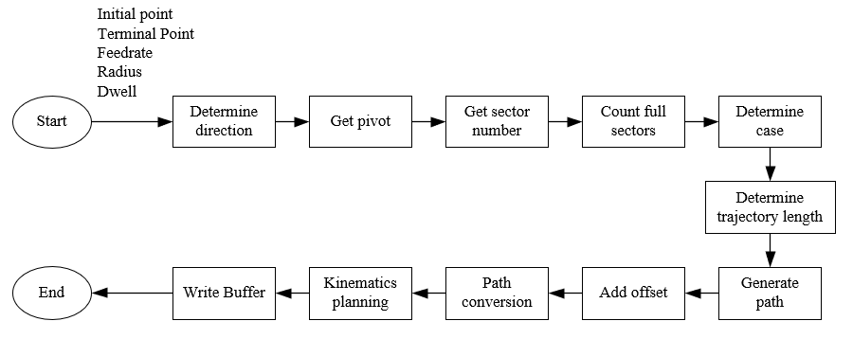

Figure XXX – flow chart of generating arc trajectory

### Planner algorithm

The planner algorithm is used to plan the acceleration and deceleration detail of each blocks, and the algorithm will be applied in the main loop. Before explaining the algorithm, it is necessary to introduce to the input, which is a trajectory that is presented as a triple-pointers array:

    float traj[len_traj][3][2];

The first pointer points to the sequence number of the block, while the second one points to the motor ID and the third one points to the carriage position and its velocity. The output of the algorithm is a block which is shown below.

typedef struct

{

*//generate by planner*

    uint8_t     dir[3];

    uint32_t    entry_freq[3];

    uint32_t    maximum_freq[3];

    uint32_t    leave_freq[3];

    uint32_t    accelerate_until;

    uint32_t    decelerate_after;

    uint32_t    accelerate_rate[3];

    uint32_t    decelerate_rate[3];

*//update in ISR*

    uint32_t    step[3];

    uint32_t    step_dwell;

    uint8_t     flag;

}**block_t**;

The block calculation will be executed twice, and in the first routine the direction and step amount can be easily determined by applying equation XXX, and the sign of the result represent the carriage direction.

|  |  |
| --- | --- |
| $$step=\frac{p_c-p_l}{res}$$ |  |

Where,

$p_c$ is the current carriage position [mm]

$p_l$ is the last carriage position [mm]

$res$ is the resolution [mm]

Then, the velocity that calculated with Jacobian matrix is defined as the maximum velocity in millimetre per second. While, the velocity can be convert to the stepper frequency easily with equation XXX.

$$step per unit=\frac{2π}{l×n×θ}$$

Where,

$l$ is the tooth length

$n$ is the amount of teeth on the pully

$θ$ is angle of a unit step

The entry frequency equals to the leave frequency of the last block, and the leave frequency of a new block is set to 0, because all the motors have to stop after executing the last block. There is no adopt that the motors should accelerate as fast as possible, but all the motors should both accelerate and decelerate at the same time, which means the proportion between the acceleration of each motor should be the same as their frequency difference proportion. Moreover, the acceleration of the motor that has the largest frequency difference should be the maximum acceleration that the motor allowed.

When the accelerations and decelerations are determined, the steps that needed can be also worked out.

|  |  |
| --- | --- |
| Inputs | Outputs |
| * Starting speed [mm/s] * Maximum speed [mm/s] * Finishing speed [mm/s] * Acceleration [mm/s] * Deceleration [mm/s] * Total steps | * Steps for acceleration * Steps for constant speed * Steps for deceleration |

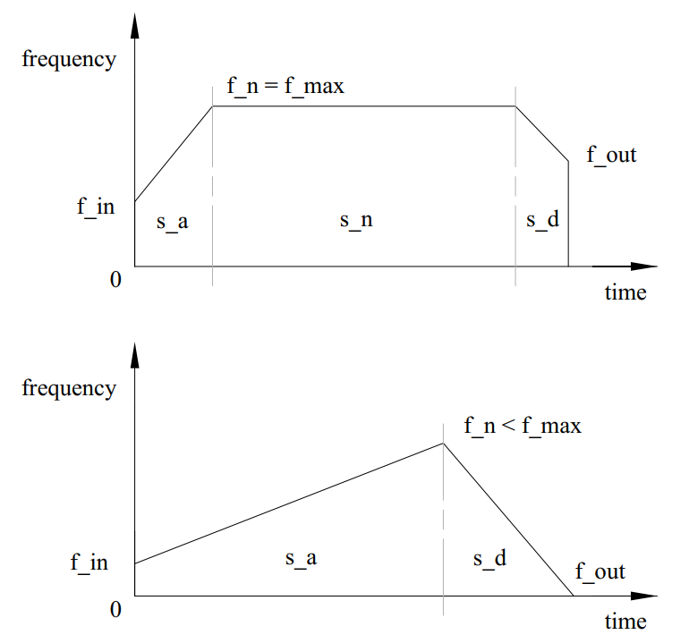

Figure XXX – Triangular (left) and trapezoidal (right) speed profile

Assume the motion cure meets the triangular condition, then the total distance is the sum of the acceleration distance and deceleration distance which can be presented:

$$s=s_{a}+s_{d}=v_{in}×t_{a}+\frac{1}{2}×a{\left(t_{a}\right)}^{2}+v_{out}×t_{d}+\frac{1}{2}×d{\left(t_{d}\right)}^{2}$$

And the velocity equation can be presented:

$$a×t_{a}=d×t_{d}$$

Rearranging equation XXX and equation XXX, the acceleration time can be calculated:

$$s=v_{in}×t_{a}+\frac{1}{2}×a{\left(t_{a}\right)}^{2}+v_{out}×\frac{a}{d}×t_{a}+\frac{1}{2}×\frac{a^{2}}{d}×{\left(t_{a}\right)}^{2}$$

$$\frac{a}{2}\left(1+\frac{a}{d}\right){\left(t_{a}\right)}^{2}+\left(v_{in}+v_{out}×\frac{a}{d}\right)×t_{a}-s=0$$

$$t_{a}=\frac{-\left(v_{in}+v_{out}×\frac{a}{d}\right)+\sqrt{{\left(v_{in}+v_{out}×\frac{a}{d}\right)}^{2}+2as(1+\frac{a}{d})}}{a\left(1+\frac{a}{d}\right)}$$

Then, it is straight forward to calculate the peak velocity:

$$v_{n}=a×t_{a}$$

If the peak velocity is larger than the maximum velocity, then the motion profile is trapezoidal, and the acceleration time $t_{a}$ should be calculated again:

$$t_{a}=\frac{\left(v_{max}-v_{in}\right)}{a}$$

And deceleration time:

$$t_{d}=\frac{\left(v_{max}-v_{out}\right)}{d}$$

The distance travelled during acceleration and deceleration can be determined:

$$s_{a}=v_{in}×t_{a}+\frac{1}{2}a{\left(t_{a}\right)}^{2}$$

$$s_{d}=v_{out}×t_{a}×\frac{d}{a}+\frac{1}{2}d{\left(t_{a}×\frac{d}{a}\right)}^{2}$$

$$s_{n}=s-s_{a}-s_{d}$$

Hence, the distance travelled in all stages are defined. However, if the peak velocity is smaller than the maximum velocity, which means the motion profile is triangular and the acceleration time $t_{a}$ do not need to be calculated again. The distance can be calculated by repeating equation XX and equation XX.

### Stepper control algorithm

The purpose of the stepper motor control algorithm is to update the motor parameters in real time, so that they can keep the preset speed and acceleration. As a result, the algorithm will be applied in a timer interrupt function and that means the algorithm cannot include complex calculations or float operations.

According to the method introduced in XXX, the principle of generating pulse signal is to set and reset an output bit and then update the timer delay. However, this algorithm has a drawback which is another algorithm needed to be designed to manage the delays when the amount of motors is increasing. Besides, there is another way which is using the PWM generating function.

The PWM function is based on timers, and the timers selected are called general-purpose timers which consist of 16-bit auto-reload counter driven by a programmable prescaler. The timers are completely independent, and do not share any resources, so that the efficiency of executing the main loop can be improved.

The function of calculating the timer is:

|  |  |
| --- | --- |
| $$T_{out}=(\left(arr+1\right)*(psc+1))/T_{clk}$$ |  |

Where $T_{clk}$ is the input frequency 84MHZ, $T_{out}$ is the overflow time, $psc$ is the prescaler and $arr$ is auto reload register .

The prescaler can divide the counter clock frequency by any factor between 1 and 65536. It

is based on a 16-bit counter controlled through a 16-bit/32-bit register (in the TIMx_PSC

register). It can be changed on the fly as this control register is buffered. The new prescaler

ratio is taken into account at the next update event.

Figure XXX shows how an acceleration is applied. The top of the figure is a v-t graph which represents how the motor or carriage accelerate from the entry speed to operation speed. The entry speed can be easily get from the pre scalar register of the corresponding stepper motor.

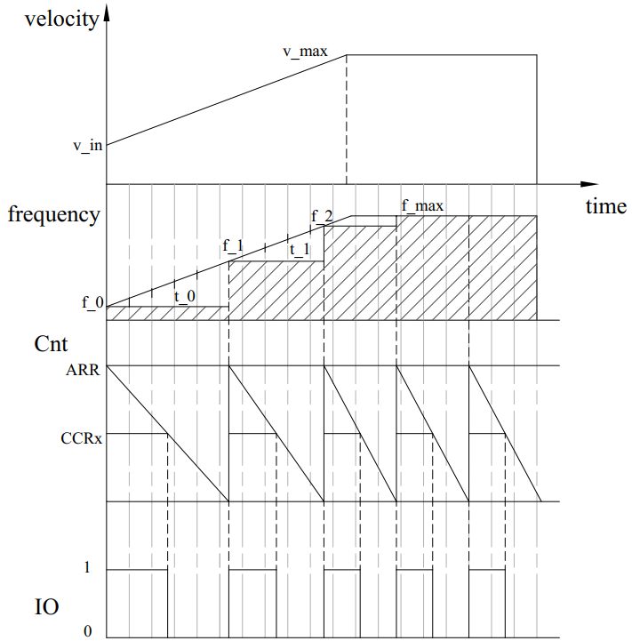

$$v_{i}=v_{i-1}+a∙t_{i-1}$$

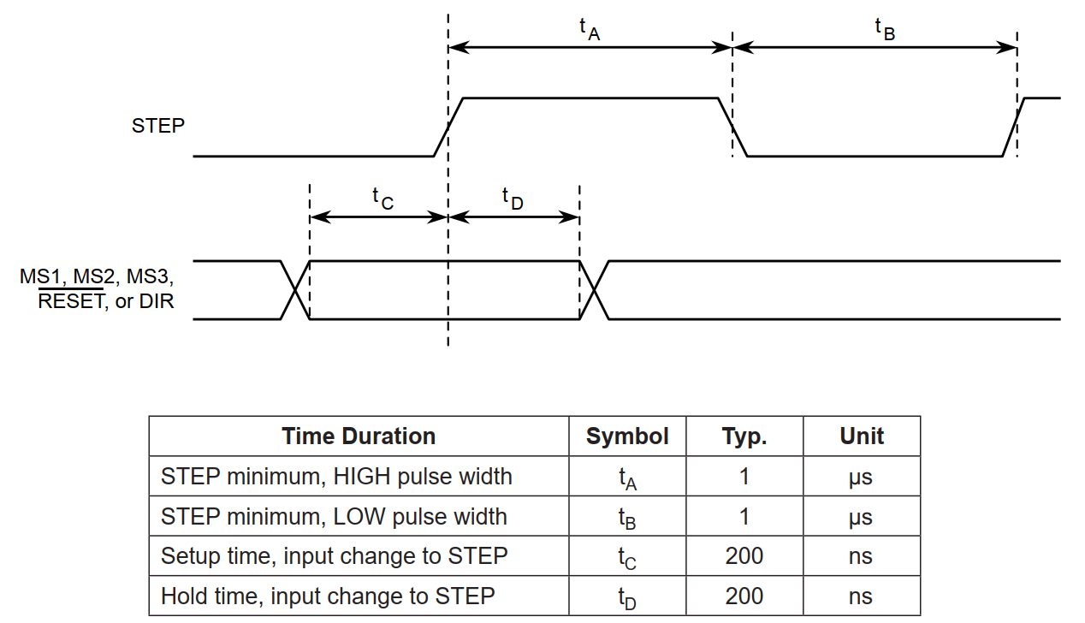

# Results

Following the method, a section containing the results of the process (experiment, simulation, design etc.) will be presented. This section will clearly collate results in an appropriate form (graphs, tables, drawings) depending upon the type of project. It is crucial that results are provided in a critical and objective manner. The language which is used should provide the reader with a clear and unbiased review of the outcome of the method. If there are limitations to the accuracy or validity of results then this should be made clear.

In this chapter, the results of this project will be presented. First, a set of pictures of the prototype will be displayed; then the acceleration curves that plotted with STM Studio will be shown to find out how the motors respond to a command, at the same time, the IO state will be plotted as the PWM wave; after that, the result of kinematics simulation with Matlab will be presented.

## Mechanism of the robot

The overall design is shown in figure 4.1.1. The robot weights 5 kg

Figure 4.1.1 – The prototype

The carriages, end effector and other small parts are made up of UV Curable Resin.

Figure 4.1.2 – 3D printed parts

The end effector is now fixed with a pencil, which can be used to record the actual path. The distance between the peak and end effector center is 10 mm, and the end effector assembly wights 100g, of which the influence of weight can be ignored as comparing the motor inertia.

Figure 4.1.3 – end effector with a pencil

The circuit is built on a breadboard, which consists of three A4988 stepper motor drivers. All the chips are covered with radiator

Figure 4.1.4 – Circuit of the prototype

## Acceleration curve

Since there is no encoder used on the design, the result of motor tests is got from STM studio by detecting the value of the specific variables.

Figure 4.2.1 -

Figure 4.2.2

Figure 4.2.3

Figure 4.2.4 – response of dwell

## PWM response

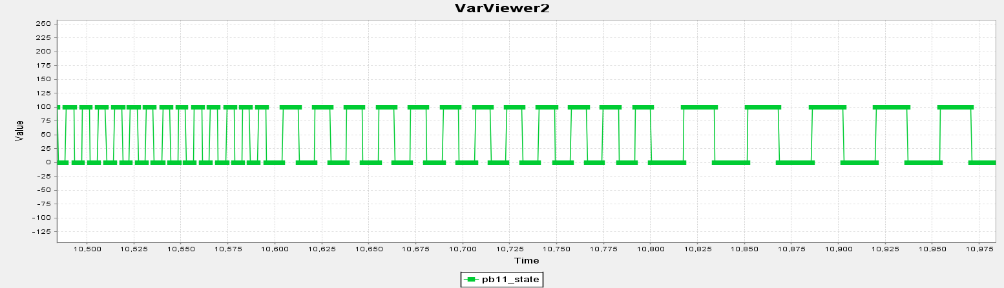

## Kinematics simulation

All points on matlab, find improvement

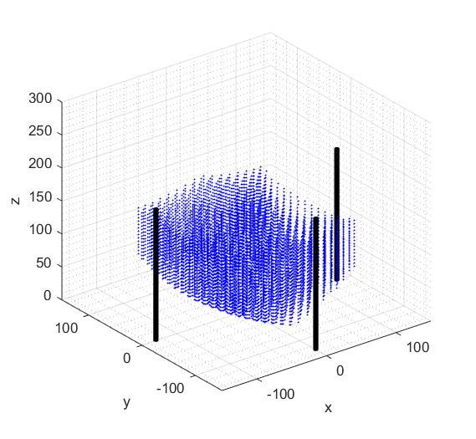

Figure XXX is the x-y sight of the workspace. The result shows that plotted points can be more suitable to a cartesian coordinate system if the cartesian coordinate system is rotated 45 degree around z axis in either directions. Besides the distance between each points is much wider than those close to the edge. As a result, errors must exist if the cartesian coordinate system is applied directly onto the path generator. On the other hand, it is necessary to add filter to minimize the average error.

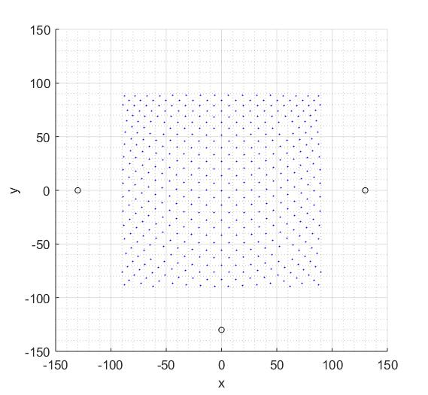

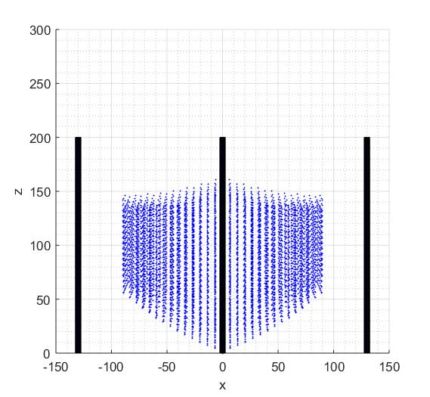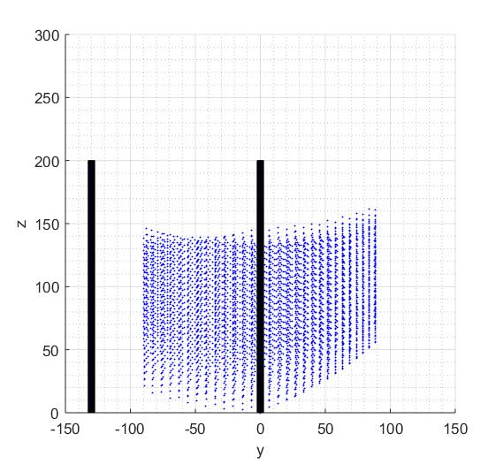

## Robot configuration result

# Discussion

The discussion is probably the single most important section of the report. It is in this section where the author has an opportunity to analyse and evaluate the results and to present the findings to the reader in the clearest way possible. The discussion should never simply summarise what has been done. 3300 words

In this chapter, the results and findings will be discussed and evaluated. The evaluation will be carried out around the following themes: whether the design can be improved to mass production; advantage and disadvantage of the technical that is used on this project as comparing with current commercial products; feasible method to improve the robot performance

## Robot structure

The previous paragraph has proved the feasibility and reliability of the structure, so in this paragraph,

### Structure optimizes

The biggest difference between a prototype and production model is that the previous one is used to proof the principal and theories work, which means inaesthetic,

### Assembly convenience

The biggest problem during assembly is to find the position of the limit switch.

## Hardware evaluation

### 8 bit processor and 32 bit processor

### Alternative motor driver

resolution

Standard library

Stm cubic + hal library

Arduino

IO allocating, capacitor, A4988 IO,

**Micro controller**

Although most of the production models use 8-bit processors because of the cost, but there are still a lot of engineers trying to replant the program to a 32-bit processor, or even ARM Cortex.

The advantage

The micro controller chosen is STM32F407, which is a 32-bit CPU with 100 IOs, 15 EXTI (external interrupt) lines, 6 UART (Universal Asynchronous Receiver/Transmitter) lines and 10 timers. While, many home 3d printer models are equipped with ATMega2560 which is a 8-bit AVR micro controller. The advantage of 32-bit processor is that it has a wide data pipe, and provides more addresses than the 8 bit one. For example, a single integer occupies 4 bits and have a range of $2^{32}$ in a 32-bit CPU, but only occupies 2 bits and have a range of $2^{16}$ in an 8-bit CPU. As a result, programming for an 8-bit CPU should always check the range of each variable in order to prevent overflow. Another reason is that the purpose of this project is to build the prototype which needs hardware resources for innovations and tests, and ATMega2560 is more suitable for mass production models.

## Program evaluation

### File structure

### Versatility

### Feasibility on RTOS

### Interrupt preempted

## Algorithm evaluation

### Forward kinematics algorithm

### Motor driver algorithm

Ramp speed profile

The timers are completely independent, and do not share any resources.

Generally, the problem of generating appropriate speed profile to a stepper motor we can split in the two main tasks: 1) to determine a shape the speed change and 2) generate impulses in appropriate instant of time in order to achieve this speed.

Operation mode of the first group of algorithms can be briefly described as: (i) calculate time period to next pulse, (ii) wait until that much time period elapses, (iii) generate next pulse and (iv) go back to step (i) and repeat until desired number of pulses is over. The another group of algorithms have an operation mode that is significantly differently, and briefly can be described as: (i) check the current time, (ii) multiply it by speed, to get expected current position, (iii) if difference from expected and actual current position greater than or equal one step, then to generate new pulse and (iv) repeat this until the final desired position is achieved.

Time of stopping and starting of a stepper motor loaded with torque is different irrespective of the obtained maximum torque, rotational speed and type of step control. Significant oscillations of torque during motor stopping have been observed (Fig. 2). The higher the rotational speed, the lower the torque becomes until the motor stops spontaneously for the load equal to zero (Fig. 3). Operation of the stepper motor during control with microstep 1/128 allows to achieve the lowest maximal rotational speed for different types of control. While the highest values of

maximal speed were achieved during control with full-step and microstep 1/4. Microstep 1/16 control allows to achieve higher maximal speeds than half-step control. A lack of relationship between the maximal rotational speed and type of step control may result from changes in temperature of the stepper motor which were not monitored and can affect this parameter. Time of increase and reduction of the maximum torque depends on the obtained maximum torque values, type of control step and motor rotational speed. The higher the motor rotational speed, the shorter time of increase and reduction of maximum torque becomes (Fig. 4). The stepper motor moves in the direction specified in accordance with control signal and next it stops with maximum holding torque. Due to step operation of the stepper motor some vibrations occur at low speeds. The reason of their appearance is the inertia of the rotor and axle loads. The motor exceeds the set position and then returns to the desired position - it takes some time to reach

the desired position. Stepper motor has also different vibration characteristic for the given mechanical system frequency. Segmentation of a step on microsteps leads to increase of resolution and this should increase the smoothness of work. The application of microstep is the reason of high reduction of the input energy because of pulsation of input energy – this leads to motor resonance [8].

### Variable types

# Conclusion

The conclusions section will provide a clear and concise summary of the main findings of the project and will give the author an opportunity to offer recommendations. By definition, there should be no findings given in the conclusions which have not previously been covered in the discussion.